 Heidegger K

Lookit! It’s a bumble! (it goes, “bumble.”) so cute!



A frower! (it’s pwetty) so sweet and so gentle!

“Bumblebees are spiffing creatures, ne?”

Heidegger K 1
“Bumblebees are spiffing creatures, ne?” 2
this file cut to lcd soundsystem 4
Notes 5
poetics 1nc [preface] 6
poetics 1nc [preface] 7
poetics 1nc [climate change] 8
poetics 1nc [climate change] 9
poetics 1nc [climate change] 10
poetics 1nc [climate change] 11
poetics 1nc [climate change] 12
Shell 13
Shell 14
Shell 15
2NC Overview [Substantive, Short] 16
2NC Overview [Substantive, Long] 17
2NC Starlight (1/3) 18
2NC Starlight (2/3) 19
2NC Starlight (3/3) 20
2NC XT / Case Turn 21
2NC XT / Case Turn 22
2NC XT / Case Turn 23
2NC XT / Case Turn 24
2NC XT / Case Turn 25
2NC You Gotta Defend Your Shit, Yo 26
AT: P / Both (1/4) 27
AT: P / Both (2/4) 28
AT: P / Both (3/4) 29
AT: P / Both (4/4) 30
AT: P / All Other Instances 31
AT: Cohran 32
AT: Technology Goggles (1/3) 33
AT: Technology Goggles (2/3) 34
AT: Technology Goggles (3/3) 35
AT: Infinite Justice [Derrida] 36
AT: Truth Exists [Sokal-Style Args] 37
AT: Political Engagement / Ceding the Political 38
AT: Alt Doesn’t End All Technological Thought 39
AT: Alt Doesn’t End All Technological Thought 40
AT: Alt Solves Residual Links (Perm Warrant) 41
AT: No Scenario 42
AT: Impact N/U 43
AT: Rose [Calculation = Responsibility/Ethics] 44
AT: Ketels 45
AT: Must Act (1/3) 46
AT: Must Act (2/3) 47
AT: Must Act (3/3) 48
AT: Individual Choice Solves Vlife 49
AT: Latour 50
AT: Nazism Turn (1/6) 51
AT: Nazism Turn (2/6) 52
AT: Nazism Turn (3/6) 53
AT: Nazism Turn (4/6) 54
AT: Nazism Turn (5/6) 55
AT: Nazism Turn (6/6) 56
AT: Ethics > Ontology (1/3) 57
AT: Ethics > Ontology (2/3) 58
AT: Ethics > Ontology (3/3) 59
Impact – Dillon [ZP to the HC] 60
Impact – Disposability 61
Link – Ethics 62
Link – International Relations (1/3) 63
Link – International Relations (2/3) 64
Link – International Relations (3/3) 65
Link – Energy 66
Link – Nuclear War 67
*Random* 68
Askesis Alternative 69
XT / Meditative Thought Solves 70

this file cut to lcd soundsystem

“Look! It’s a bumble!”

“I rather like bumbles. They’re gentle creatures.”

Notes

One thing to note, besides the prevalence of bumbles in this file, is the distinction between technology proper and technological thought. We only reject the latter, not the former. Post-alt, we still have technology, we just use/view it in a different way. In fact, you probably “solve” – don’t use the word “solve” – for the worst parts of technology proper, as meditative thinking would theoretically increase insights on use. Keep this in mind when the aff tries to impact turn. (I believe there’s a Beckmann 2 card that Mr. Zavell is putting out in his file which illustrates this point more clearly.)

Also keep in mind that a large number of typical 2ac answers will just be more links. You should point that out.

If you want a longer shell, read some of the 2NC case turn ev, it’s pretty good stuff.

Lastly, you HAVE to highlight this file before rounds if you mean to run it – a lot of was cut from books, and I don’t have a decent OCR, so I was unable to underline those cards.

poetics 1nc [preface]

Knowing robs us of wonder.
Had it not ripped apart
the fearful robes of primordial Night
to steal the force that crafted horns
on doghead and sowed insurrection
overnight in the homely beak
of a hen; had reason not given us
assurance that day will daily break
and the sun's array return to disarm
night's fantastic figurations--
each daybreak
would be garlanded at the city gate
and escorted with royal drums
to a stupendous festival
of an amazed world.
One day
after the passage of a dark April storm
ecstatic birds followed its furrows
sowing songs of daybreak though the time
was now past noon, their sparkling
notes sprouting green incantations
everywhere to free the world
from harmattan death.
But for me
the celebration is make-believe;
the clamorous change of season
will darken the hills of Nsukka
for an hour or two when it comes;
no hurricane will hit my sky--
and no song of deliverance.

poetics 1nc [preface]

This is Martin Heidegger, writing in 1949 in the book The Question Concerning Technology:

The question concerning technology is the question concerning the constellation in which revealing and concealing, in which the essential unfolding of truth propriates. But what help is it to us to look into the constellation of truth? We look into the danger and see the growth of the saving power. Through this we are not yet saved. But we are thereupon summoned to hope in the growing light of the saving power. How can this happen? Here and now and in little things, that we may foster the saving power in its increase. This includes holding always before our eyes the extreme danger. The essential unfolding of technology threatens revealing, threatens it with the possibility that all revealing will be consumed in ordering and that everything will present itself only in the unconcealment of standing-reserve. Human activity can never directly counter this danger. Human achievement alone can never banish it. But human reflection can ponder the fact that all saving power must be of a higher essence than what is endangered, though at the same time kindred to it. But might there not perhaps be a more primally granted revealing that could bring the saving power into its first shining-forth in the midst of the danger that in the technological age rather conceals than shows itself? At the outset of the destining of the West, in Greece, the arts soared to the supreme height of the revealing granted them. They illuminated the presence [Gegenwart] of the gods and the dialogue of divine and human destinings. And art was called simply techne. It was a single, manifold revealing. It was pious, promos, i.e., yielding to- the holding sway and the safekeeping of truth. The arts were not derived from the artistic. Artworks were not enjoyed aesthetically. Art was not a sector of cultural activity. What was art—perhaps only for that brief but magnificent age? Why did art bear the modest name techne? Because it was a revealing that brought forth and made present, and therefore belonged within poiesis. It was finally that revealing which holds complete sway in all the fine arts, in poetry, and in everything poetical that obtained poiesis as its proper name. The same poet from whom we heard the words But where danger is, grows there the saving power also . . . says to us: poetically man dwells on this earth. The poetical brings the true into the splendor of what Plato in the Phaedrus calls to ekphanestaton, that which shines forth most purely. The poetical thoroughly pervades every art, every revealing of essential unfolding into the beautiful. Could it be that the fine arts are called to poetic revealing? Could it be that revealing lays claim to the arts most primally, so that they for their part may expressly foster the growth of the saving power, may awaken and found anew our vision of, and trust in, that which grants? Whether art may be granted this highest possibility of its essence in the midst of the extreme danger, no one can tell. Yet we can be astounded. Before what? Before this other possibility: that the frenziedness of technology may entrench itself everywhere to such an extent that someday, throughout everything technological, the essence of technology may unfold essentially in the propriative event of truth. Because the essence of technology is nothing technological, essential reflection upon technology and decisive confrontation with it must happen in a realm that is, on the one hand, akin to the essence of technology and, on the other, fundamentally different from it. Such a realm is art. But certainly only if reflection upon art, for its part, does not shut its eyes to the constellation of truth, concerning which we are questioning. Thus questioning, we bear witness to the crisis that in our sheer preoccupation with technology we do not yet experience the essential unfolding of technology, that in our sheer aesthetic-mindedness we no longer guard and preserve the essential unfolding of art. Yet the more questioningly we ponder the essence of technology, the more mysterious the essence of art becomes. The closer we come to the danger, the more brightly do the ways into the saving power begin to shine and the more questioning we become. For questioning is the piety of thought.

poetics 1nc [climate change]

What does science see when it looks at the evening sky, cast grey-blue in azure hues and shades? The answer, of course, is differentially refracted photons manifesting at a wavelength of 475 nanometers, entering your eyes and colliding with the rod and cone structures in your eyes. But that means nothing much in terms of human signification, doesn’t it?

So, what is it mean, then, to know something? When you see black clouds of smog rising above industrial factories, what feelings arise in you? When the world blackens in carbon soot and the forests wither and die, what does that mean for human consciousness? These are all questions the affirmative deals with without dealing with. So, here’s our question: what does it mean to know global warming, which they claim to solve?

Listening to the 1ac, you might think this: emissions cause carbon concentration and greenhouse gases shutting in heat and thus we should provide x incentive to decrease emissions preventing warming and otherwise people will die or we’ll go extinct.

We think that’s rather dimensionless. Whatever happened to the island nation resident, slowly watching the waters rise and his life wash away? Or, perhaps, the lifelong farmer, watching his crops grow less and less each year? Whatever happened to them and a million other people, all missing from the 1ac? They are replaced by objective knowledges and descriptions, by solvency mechanisms and well-written plans. But even you. Have you ever seen an ice cap glimmering on a mountaintop? Will your children or your children’s children even know what an ice cap is? Does that matter?

But first, another question: How did we get here? Why, since the Industrial Revolution, have we continued our engagement with technology, and wanted more and more? Why have the last few decades of federal policy for incentivizing energy failed so miserably and terribly? What is greed and consumption and why do we continue on our curve into the abyss? For the heart of the darkness of the way humanity is now, can the technical approach of the affirmative do much? When they sat at a computer all day for days on end, weeks on end, googling and lexis-ing and looking up words like “extinction” and “nuclear war,” how did the thoughts in their minds take shape?

So really, what’s wrong with things?

We’ll tell you. The 1ac – in its presentation, style, analysis, and conceptualization of the problem of climate change, in its the entire assemblage of thought and ontology meant to frame the round in a certain way, is technological. It is management. It reveals the world as temporally linear and causally ordered, when in fact we know that nothing can take human experience and cut it into explainable bits. The 1ac is a forgetting of the poetics of our existence, a forgetting of song and unfolding dream. Even our forgetting is eventually forgotten. In the 2ac, the affirmative will desperately try to secure and close the world we’ve uncovered. Of course, all that is left is a need for more knowledge, for more management.

poetics 1nc [climate change]

We quote LaDelle McWhorter, writing in the book Heidegger and the Earth, in 1992:

What it most illustrative is often also what is most common. Today, on all sides of ecological debate we hear, with greater and greater frequency, the word management. On the one hand, business people want to manage natural resources so as to keep up profits. On the other hand, conservationists want to manage natural resources so that there will be plenty of coal and oil and recreational facilities for future generations. These groups and factions within them debate vociferously over which management policies are the best, that is, the most efficient and manageable. Radical environmentalists damn both groups and claim it is human population growth and rising expectations that are in need of management. But wherever we look, wherever we listen, we see and hear the term management. We are living in a veritable age of management. Before a middle class child graduates from high school she or he is already preliminarily trained in the arts of weight management, stress management, and time management, to name just a few. As we approach middle age we continue to practice these essential arts, refining and adapting our regulatory regimes as the pressures of life increase and the body begins to break down. We have become a society of managers - of our homes, careers, portfolios, estates, even of our own bodies - so is it surprising that we set ourselves up as the managers of the earth itself? And yet, as thoughtful earth-dwellers we must ask, what does this signify? In numerous essays - in particular the beautiful 1953 essay, "The Question Concerning Technology" - Heidegger speaks of what he sees as the danger of dangers in this, our age. This danger is a kind of forgetfulness – a forgetfulness that Heidegger thought could result not only in nuclear disaster or environmental catastrophe, but in the loss of what makes us the kind of beings we are, beings who can think and who can stand in thoughtful relationship to things. This forgetfulness is not a forgetting of facts and their relationships; it is a forgetfulness of something far more important and far more fundamental than that. He called it forgetfulness of 'the mystery.’ It would be easy to imagine that by 'the mystery' Heidegger means some sort of entity, some thing, temporarily hidden or permanently ineffable. But 'the mystery is not the name of some thing; it is the event of the occurring together of revealing and concealing. Every academic discipline, whether it be biology or history, anthropology or mathematics, is interested in discovery, in the 'revelation of new truths" Knowledge, at least as it is institutionalized in the modern world is concerned, then, with what Heidegger would call revealing, the bringing to light, or the coming to presence of things. However, in order for any of this revealing to occur, Heidegger says, concealing must also occur. Revealing and concealing belong together. Now, what does this mean? We know that in order to pay attention to one thing, we must stop paying close attention to something else. In order to read philosophy we must stop reading cereal boxes. In order to attend to the needs of students we must sacrifice some of our research time. Allowing for one thing to reveal itself means allowing for the concealing of something else. All revealing comes at the price of concomitant concealment. But this is more than just a kind of Kantian acknowledgment of human limitation. Heidegger is not simply dressing up the obvious, that is, the fact that no individual can undergo two different experiences simultaneously. His is not a point about human subjectivity at all. Rather, it is a point about revealing itself. When revealing reveals itself as temporally linear and causally ordered, for example, it cannot simultaneously reveal itself as ordered by song and unfolding dream. Furthermore, in revealing, revealing itself is concealed in order for what is revealed to come forth. Thus, when revealing occurs concealing occurs as well. The two events are one and cannot be separated. Too often we forget. The radiance of revelation blinds us both to its own event and to the shadows that it casts, so that revealing conceals itself and its self-concealing conceals itself, and we fall prey to that strange power of vision to consign to oblivion whatever cannot be seen. Even our forgetting is forgotten, and all races of absence absent themselves from our world. The noted physicist Stephen Hawking, in his popular book A Brief History of Time, writes, "The eventual goal of science is to provide a single theory that describes the whole universe.,'5 Such a theory, many people would assert, would be a systematic arrangement of all knowledge both already acquired and theoretically possible. lt would be a theory to end all theories, outside of which no information, no revelation could, or would need to, occur. And the advent of such a theory would be as the shining of a light into every corner of being. Nothing would remain concealed. This dream of Hawking's is a dream of power; in fact, it is a dream of absolute power, absolute control. It is a dream of the ultimate managerial utopia. This, Heidegger would contend, is the dream of technological thought in the modern age. We dream of knowing, grasping everything, for then we can control, then we can manage, everything. But it is only a dream, itself predicated, ironically enough, upon concealment, the self-concealing of the mystery. We can never control-the mystery the belonging together of revealing and concealing. In order to approach the world in a manner exclusively technological, calculative, mathematical, scientific, we must already have given up (or lost, or been expelled by, or perhaps ways of being such as we are even impossible within) other approaches or modes of revealing that would unfold into knowledges of other sorts. Those other approaches or paths of thinking must already have been obliterated; those other knowledges must already have concealed themselves in order for technological or scientific revelation to occur. The danger of a managerial approach to the world lies not then in what it knows nor in its planetary on into the secrets of galactic emergence or nuclear fission – but in what it forgets, what it itself conceals. It forgets that any other truths are possible, and it forgets that the belonging together of revealing with concealing is forever beyond the power of human management. We can never have, or know, it all; we can never manage everything.

poetics 1nc [climate change]

So, now, why does this forgetting matter? “So?” is what the aff might say in the 2ac. “So?” is an interesting question. Indeed, so what? Our answer is, we don’t know. And that’s precisely it. The poet John Keating once said, “Truth is beauty, and beauty truth.” So, it’s love and truth and beauty and honor and mercy and compassion and all the things that make up humanity. There isn’t a way we can objectively give that a value, but that misses the point. Should we give it a monetary value, like all the magazine-recommended plastic spread around in houses across America? Should we give it an ideological value, like the cry of “freedom” that heralded the troops blasting their way into Iraq after 9/11? No. But, we feel we want to preserve it. There is something there intangible and beautiful and unexplainable by the technicality of the affirmative, and that is worth more than any scenario they can invent.

We’re not so radical, though. We aren’t asking for everyone to abandon their houses and throw away their iPods, to retreat into the forests and not wear clothing. There’s a difference between abandoning technology and technological thought. We want to coexist with technology in a way that doesn’t deny our humanity.

Thus, we offer poetry and our criticism as a performative opening of meditative thought.

poetics 1nc [climate change]

Quoting Martin Heidegger in 1966, writing in Discourse on Thinking, gender paraphrased:

Is man, then, a defenseless and perplexed victim at the mercy of the irresistible superior power of technology? He would be if man today abandons any intention to pit meditative thinking decisively against merely calculative thinking. But once meditative thinking awakens, it must be at work unceasingly and on every last occasion—hence, also, here and now at this commemoration. For here we are considering what is threatened especially in the atomic age: the autochthony of the works of [hu]man[ity]. Thus we ask now: even if the old rootedness is being lost in this age, may not a new ground and foundation be granted again to man, a foundation and ground out of which man's nature and all his works can flourish in a new way even in the atomic age? What could the ground and foundation be for the new autochthony? Perhaps the answer we are looking for lies at hand; so near that we all too easily overlook it. For the way to what is near is always the longest and thus the hardest for us humans. This way is the way of meditative thinking. Meditative thinking demands of us not to cling one-sidedly to a single idea, nor to run down a one-track course of ideas. Meditative thinking demands of us that we engage ourselves with what at first sight does not go together at all. Let us give a trial. For all of us, the arrangements, devices, and machinery of technology are to a greater or lesser extent indispensable. It would be foolish to attack technology blindly. It would be shortsighted to condemn it as the work of the devil. We depend on technical devices; they even challenge us to ever greater advances. But suddenly and unaware we find ourselves so firmly shackled to these technical devices that we fall into bondage to them. Still we can act otherwise. We can use technical devices, and yet with proper use also keep ourselves so free of them, that we may let go of them any time. We can use technical devices as they ought to be used, and also let them alone as something which does not affect our inner and real core. We can affirm the unavoidable use of technical devices, and also deny them the right to dominate us, and so to warp, confuse, and lay waste our nature. But will not saying both yes and no this way to technical devices make our relation to technology ambivalent and insecure? On the contrary! Our relation to technology will become wonderfully simple and relaxed. We let technical devices enter our daily life, and at the same time leave them outside, that is, let them alone, as things which are nothing absolute but remain dependent upon something higher. I would call this comportment toward technology which expresses "yes" and at the s time "no," by an old word, releasement towards things. Having this comportment we no longer view things only in a technical way. It gives us clear vision and we notice that while the production and use of machines demands of us another relation to things, it is not a meaningless relation. Farming and agriculture, for example, now have turned into a motorized food industry. Thus here, evidently, as elsewhere, a profound change is taking place in man's relation to nature and to the world. But the meaning that reigns in this change remains obscure. There is then in all technical processes a meaning, not invented or made by us, which lays claim to what man does and leaves undone. We do not know the significance of the uncanny increasing dominance of atomic technology. The meaning pervading technology hides itself. But if we explicitly and continuously heed the fact that such hidden meaning touches us everywhere in the world of technology, we stand at once within the realm of that which hides itself from us, and hides itself just in approaching us. That which shows itself and at the same time withdraws is the essential trait of what we call the mystery. I call the comportment which enables us to keep open to the meaning hidden in technology, openness to the mystery. Releasement towards things and openness to the mystery belong together. They grant us the possibility of dwelling in the world in a totally different way. They promise us a new ground and foundation upon which we can stand and endure in the world of technology without being imperiled by it. Releasement towards things and openness to the mystery give us a vision of a new autochthony which someday even might be fit to recapture the old and now rapidly disappearing autochthony in a changed form. But for the time being—we do not know for how long—[hu]man[ity] finds [itself] in a perilous situation. Why? Just because a third world war might break out unexpectedly and bring about the complete annihilation of humanity and the destruction of the earth? No. In this dawning atomic age a far greater danger threatens—precisely when the danger of a third world war has been removed. A strange assertion! Strange indeed, but only as long as we do not meditate. In what sense is the statement made valid? The assertion is valid in the sense that the approaching tide of technological revolution in the atomic age could so captivate, bewitch, dazzle, and beguile man that calculative thinking may someday come to be accepted and practiced as the only way of thinking. What great danger then might move upon us? Then there might go hand in hand with the greatest ingenuity in calculative planning and inventing indifference toward meditative thinking – total thoughtlessness. And then? Then [hu]man[ity] would have denied and thrown away [its] own special nature—that he is a meditative being. Therefore, the issue is the saving of [hu]man[ity]’s essential nature. Therefore, the issue is keeping meditative thinking alive. Yet releasement toward things and openness to the mystery never happen of themselves. They do not befall us accidentally. Both flourish only through persistent, courageous thinking.

poetics 1nc [climate change]

Finally, we wish offer a role of the ballot: to decide between calculative and meditative forms of thought. The affirmative will doubtless protest that climate change still matters, that, regardless of all our wishful dreaming, people will still die. That misses the point, for it is the thoughtless movement of human action that has brought us here in the first place. We invite you to tarry, to wait, to wander, to delink thinking climate from thinking death and thinking technology.

Again quoting LaDelle McWhorter in 1992, from the same book:

When we attempt to think ecologically and within Heidegger's discourse (or perhaps better: when we attempt to think Heideggerly within ecological concerns), the paradoxical unfolds at the site of the question of human action. Thinking ecologically - that is, thinking the earth in our time - means thinking death; it means thinking catastrophe; it means thinking the possibility of utter annihilation not just for human being but for all that lives on this planet and for the living planet itself. Thinking the earth in our time means thinking what presents itself as that which must not be allowed to go on, as that which must be controlled, as that which must be stopped. Such thinking seems to call for immediate action. There is no time to lose. We must work for change, seek solutions, curb appetites, reduce expectations, find cures now, before the problems become greater than anyone's ability to solve them - if they have not already done so. However, in the midst of this urgency, thinking ecologically, thinking Heideggerly, means rethinking the very notion of human action. It means placing in question our typical Western managerial approach to problems, our propensity for technological intervention, our belief in human cognitive power, our commitment to a metaphysics that places active human being over against passive nature. For it is the thoughtless deployment of these approaches and notions that has brought us to the point of ecological catastrophe in the first place. Thinking with Heidegger, thinking Heideggerly and ecologically, means, paradoxically, acting to place in question the acting subject, willing a displacing of our will to action; it means calling ourselves as selves to rethink our very selves, insofar as selfhood in the West is constituted as agent, as actor, as controlling ego, as knowing consciousness. Heidegger's work calls us not to rush in with quick solutions, not to act decisively to put an end to deliberation, but rather to think, to tarry with thinking unfolding itself to release ourselves to thinking without provision or predetermined aim.

Shell

Management of alternative energy reveals the world through particular, ordered ontologies, causing us to forget other and more subtle modes of being. This incomplete, ideologically framed knowledge causes nuclear war and environmental catastrophe, turning case.

LaDelle McWhorter, Professor of Philosophy, Northeast Missouri State, also of the bumbles, 1992, Heidegger and the Earth, ed. McWhorter.

What it most illustrative is often also what is most common. Today, on all sides of ecological debate we hear, with greater and greater frequency, the word management. On the one hand, business people want to manage natural resources so as to keep up profits. On the other hand, conservationists want to manage natural resources so that there will be plenty of coal and oil and recreational facilities for future generations. These groups and factions within them debate vociferously over which management policies are the best, that is, the most efficient and manageable. Radical environmentalists damn both groups and claim it is human population growth and rising expectations that are in need of management. But wherever we look, wherever we listen, we see and hear the term management. We are living in a veritable age of management. Before a middle class child graduates from high school she or he is already preliminarily trained in the arts of weight management, stress management, and time management, to name just a few. As we approach middle age we continue to practice these essential arts, refining and adapting our regulatory regimes as the pressures of life increase and the body begins to break down. We have become a society of managers - of our homes, careers, portfolios, estates, even of our own bodies - so is it surprising that we set ourselves up as the managers of the earth itself? And yet, as thoughtful earth-dwellers we must ask, what does this signify? In numerous essays - in particular the beautiful 1953 essay, "The Question Concerning Technology" - Heidegger speaks of what he sees as the danger of dangers in this, our age. This danger is a kind of forgetfulness – a forgetfulness that Heidegger thought could result not only in nuclear disaster or environmental catastrophe, but in the loss of what makes us the kind of beings we are, beings who can think and who can stand in thoughtful relationship to things. This forgetfulness is not a forgetting of facts and their relationships; it is a forgetfulness of something far more important and far more fundamental than that. He called it forgetfulness of 'the mystery.’ It would be easy to imagine that by 'the mystery' Heidegger means some sort of entity, some thing, temporarily hidden or permanently ineffable. But 'the mystery is not the name of some thing; it is the event of the occurring together of revealing and concealing. Every academic discipline, whether it be biology or history, anthropology or mathematics, is interested in discovery, in the 'revelation of new truths" Knowledge, at least as it is institutionalized in the modern world is concerned, then, with what Heidegger would call revealing, the bringing to light, or the coming to presence of things. However, in order for any of this revealing to occur, Heidegger says, concealing must also occur. Revealing and concealing belong together. Now, what does this mean? We know that in order to pay attention to one thing, we must stop paying close attention to something else. In order to read philosophy we must stop reading cereal boxes. In order to attend to the needs of students we must sacrifice some of our research time. Allowing for one thing to reveal itself means allowing for the concealing of something else. All revealing comes at the price of concomitant concealment. But this is more than just a kind of Kantian acknowledgment of human limitation. Heidegger is not simply dressing up the obvious, that is, the fact that no individual can undergo two different experiences simultaneously. His is not a point about human subjectivity at all. Rather, it is a point about revealing itself. When revealing reveals itself as temporally linear and causally ordered, for example, it cannot simultaneously reveal itself as ordered by song and unfolding dream. Furthermore, in revealing, revealing itself is concealed in order for what is revealed to come forth. Thus, when revealing occurs concealing occurs as well. The two events are one and cannot be separated. Too often we forget. The radiance of revelation blinds us both to its own event and to the shadows that it casts, so that revealing conceals itself and its self-concealing conceals itself, and we fall prey to that strange power of vision to consign to oblivion whatever cannot be seen. Even our forgetting is forgotten, and all races of absence absent themselves from our world. The noted physicist Stephen Hawking, in his popular book A Brief History of Time, writes, "The eventual goal of science is to provide a single theory that describes the whole universe.,'5 Such a theory, many people would assert, would be a systematic arrangement of all knowledge both already acquired and theoretically possible. lt would be a theory to end all theories, outside of which no information, no revelation could, or would need to, occur. And the advent of such a theory would be as the shining of a light into every corner of being. Nothing would remain concealed. This dream of Hawking's is a dream of power; in fact, it is a dream of absolute power, absolute control. It is a dream of the ultimate managerial utopia. This, Heidegger would contend, is the dream of technological thought in the modern age. We dream of knowing, grasping everything, for then we can control, then we can manage, everything. But it is only a dream, itself predicated, ironically enough, upon concealment, the self-concealing of the mystery. We can never control-the mystery the belonging together of revealing and concealing. In order to approach the world in a manner exclusively technological, calculative, mathematical, scientific, we must already have given up (or lost, or been expelled by, or perhaps ways of being such as we are even impossible within) other approaches or modes of revealing that would unfold into knowledges of other sorts. Those other approaches or paths of thinking must already have been obliterated; those other knowledges must already have concealed themselves in order for technological or scientific revelation to occur. The danger of a managerial approach to the world lies not then in what it knows nor in its planetary on into the secrets of galactic emergence or nuclear fission – but in what it forgets, what it itself conceals. It forgets that any other truths are possible, and it forgets that the belonging together of revealing with concealing is forever beyond the power of human management. We can never have, or know, it all; we can never manage everything.

Shell

Forgetting other modes of being destroys humanity’s essential nature and is a fate worse than extinction. Use of consistent meditative thought enables reconfiguring the way we dwell in the world, as well as use of technology without technological thought. We disagree with the gendered language used.

Martin Heidegger, an adorable and cute bumblebee, 1966, Discourse on Thinking, p. 52-57

Is man, then, a defenseless and perplexed victim at the mercy of the irresistible superior power of technology? He would be if man today abandons any intention to pit meditative thinking decisively against merely calculative thinking. But once meditative thinking awakens, it must be at work unceasingly and on every last occasion—hence, also, here and now at this commemoration. For here we are considering what is threatened especially in the atomic age: the autochthony of the works of man. Thus we ask now: even if the old rootedness is being lost in this age, may not a new ground and foundation be granted again to man, a foundation and ground out of which man's nature and all his works can flourish in a new way even in the atomic age? What could the ground and foundation be for the new autochthony? Perhaps the answer we are looking for lies at hand; so near that we all too easily overlook it. For the way to what is near is always the longest and thus the hardest for us humans. This way is the way of meditative thinking. Meditative thinking demands of us not to cling one-sidedly to a single idea, nor to run down a one-track course of ideas. Meditative thinking demands of us that we engage ourselves with what at first sight does not go together at all. Let us give a trial. For all of us, the arrangements, devices, and machinery of technology are to a greater or lesser extent indispensable. It would be foolish to attack technology blindly. It would be shortsighted to condemn it as the work of the devil. We depend on technical devices; they even challenge us to ever greater advances. But suddenly and unaware we find ourselves so firmly shackled to these technical devices that we fall into bondage to them. Still we can act otherwise. We can use technical devices, and yet with proper use also keep ourselves so free of them, that we may let go of them any time. We can use technical devices as they ought to be used, and also let them alone as something which does not affect our inner and real core. We can affirm the unavoidable use of technical devices, and also deny them the right to dominate us, and so to warp, confuse, and lay waste our nature. But will not saying both yes and no this way to technical devices make our relation to technology ambivalent and insecure? On the contrary! Our relation to technology will become wonderfully simple and relaxed. We let technical devices enter our daily life, and at the same time leave them outside, that is, let them alone, as things which are nothing absolute but remain dependent upon something higher. I would call this comportment toward technology which expresses "yes" and at the s time "no," by an old word, releasement towards things. Having this comportment we no longer view things only in a technical way. It gives us clear vision and we notice that while the production and use of machines demands of us another relation to things, it is not a meaningless relation. Farming and agriculture, for example, now have turned into a motorized food industry. Thus here, evidently, as elsewhere, a profound change is taking place in man's relation to nature and to the world. But the meaning that reigns in this change remains obscure. There is then in all technical processes a meaning, not invented or made by us, which lays claim to what man does and leaves undone. We do not know the significance of the uncanny increasing dominance of atomic technology. The meaning pervading technology hides itself. But if we explicitly and continuously heed the fact that such hidden meaning touches us everywhere in the world of technology, we stand at once within the realm of that which hides itself from us, and hides itself just in approaching us. That which shows itself and at the same time withdraws is the essential trait of what we call the mystery. I call the comportment which enables us to keep open to the meaning hidden in technology, openness to the mystery. Releasement towards things and openness to the mystery belong together. They grant us the possibility of dwelling in the world in a totally different way. They promise us a new ground and foundation upon which we can stand and endure in the world of technology without being imperiled by it. Releasement towards things and openness to the mystery give us a vision of a new autochthony which someday even might be fit to recapture the old and now rapidly disappearing autochthony in a changed form. But for the time being—we do not know for how long—man finds himself in a perilous situation. Why? Just because a third world war might break out unexpectedly and bring about the complete annihilation of humanity and the destruction of the earth? No. In this dawning atomic age a far greater danger threatens—precisely when the danger of a third world war has been removed. A strange assertion! Strange indeed, but only as long as we do not meditate. In what sense is the statement made valid? The assertion is valid in the sense that the approaching tide of technological revolution in the atomic age could so captivate, bewitch, dazzle, and beguile man that calculative thinking may someday come to be accepted and practiced as the only way of thinking. What great danger then might move upon us? Then there might go hand in hand with the greatest ingenuity in calculative planning and inventing indifference toward meditative thinking – total thoughtlessness. And then? Then man would have denied and thrown away his own special nature—that he is a meditative being. Therefore, the issue is the saving of man’s essential nature. Therefore, the issue is keeping meditative thinking alive. Yet releasement toward things and openness to the mystery never happen of themselves. They do not befall us accidentally. Both flourish only through persistent, courageous thinking.

Shell

Alternative Text: “Vote negative to refuse action in favor of meditative thought.”

You should ignore the aff’s siren call to action. The only way to escape the cycle of forgetting and ecological catastrophe is to stop and think. This unfolding allows the world to disclose itself to us.

LaDelle McWhorter, Professor of Philosophy, Northeast Missouri State, a joyous and happy bumble, 1992, Heidegger and the Earth, ed. McWhorter.

When we attempt to think ecologically and within Heidegger's discourse (or perhaps better: when we attempt to think Heideggerly within ecological concerns), the paradoxical unfolds at the site of the question of human action. Thinking ecologically - that is, thinking the earth in our time - means thinking death; it means thinking catastrophe; it means thinking the possibility of utter annihilation not just for human being but for all that lives on this planet and for the living planet itself. Thinking the earth in our time means thinking what presents itself as that which must not be allowed to go on, as that which must be controlled, as that which must be stopped. Such thinking seems to call for immediate action. There is no time to lose. We must work for change, seek solutions, curb appetites, reduce expectations, find cures now, before the problems become greater than anyone's ability to solve them - if they have not already done so. However, in the midst of this urgency, thinking ecologically, thinking Heideggerly, means rethinking the very notion of human action. It means placing in question our typical Western managerial approach to problems, our propensity for technological intervention, our belief in human cognitive power, our commitment to a metaphysics that places active human being over against passive nature. For it is the thoughtless deployment of these approaches and notions that has brought us to the point of ecological catastrophe in the first place. Thinking with Heidegger, thinking Heideggerly and ecologically, means, paradoxically, acting to place in question the acting subject, willing a displacing of our will to action; it means calling ourselves as selves to rethink our very selves, insofar as selfhood in the West is constituted as agent, as actor, as controlling ego, as knowing consciousness. Heidegger's work calls us not to rush in with quick solutions, not to act decisively to put an end to deliberation, but rather to think, to tarry with thinking unfolding itself to release ourselves to thinking without provision or predetermined aim.

2NC Overview [Substantive, Short]
[umm, just a little shorter that the long one, actually]

The affirmative is a process of forgetting humanity. Their revealing of the world is that of technological order – Stories and perspectives of have-nots least to blame are replaced and overwritten by objective knowledges and descriptions, the darkness of the ever-increasing human drive to technology, and the greed that is the root of all this pollution since the Industrial Revolution is replaced by a single snapshot of one problem and one solution, and the continuous drive of problem-reaction problem-reaction technological thought that has failed federal incentives for the last forty years is simply unquestioned and continued.

What we are presented with is a causally ordered, highly technical story of a problem and a solution, of internal links, impacts, and solvency – human dimensionality and thought seems to have disappeared from the discussion.

What we have forgotten is the poetics of our existence, of song and unfolding dream and the reasons that all around the world exploitation and pollution and human darkness continues – it is not for lack of a specific policy by a specific government, but for a lack of contemplation of our fundamental assumptions which shape our action, that is, for a lack of meditative thought. Nuclear war and environmental catastrophe and a forgetting of our humanity are inevitable in such a world. The alternative is thus to step away from actomania, to consider and to tarry and to wonder. You should refuse the blackmail of the aff and take the leap of faith to do nothing in the face of catastrophe.

2NC Overview [Substantive, Long]

The 1ac robs us of the more human dimensions of life, creating a fate worse than extinction.

Listening to the 1ac, you might think this: emissions cause carbon concentration and greenhouse gases shutting in heat and thus we should provide x incentive to decrease emissions preventing warming and otherwise people will die or we’ll go extinct.

We think that’s rather dimensionless. Whatever happened to the island nation resident, slowly watching the waters rise and his life wash away? Or, perhaps, the lifelong farmer, watching his crops grow less and less each year? Whatever happened to them and a million other people, all missing from the 1ac? They are replaced by objective knowledges and descriptions, by solvency mechanisms and well-written plans. Do these things matter?

But first, another question: How did we get here? Why, since the Industrial Revolution, have we continued our engagement with technology, and wanted more and more? Why have the last few decades of federal policy for incentivizing energy failed so miserably and terribly? What is greed and consumption and why do we continue on our curve into the abyss? For the heart of the darkness of the way humanity is now, can the continuous technical approach of the affirmative do much? When they sat at a computer all day for days on end, weeks on end, googling and lexis-ing and looking up words like “extinction” and “nuclear war,” how did the thoughts in their minds take shape?

So really, what’s wrong with things?

What’s wrong is that the 1ac – in its presentation and conceptualization of the problem of climate change, is management. It reveals the world as temporally linear and causally ordered, when in fact we know that nothing can take human experience and cut it into explainable bits. The 1ac is a forgetting of the poetics of our existence, a forgetting of song and unfolding dream. Even our forgetting is eventually forgotten. All the aff can do is continue the disastrous politics that are the root cause of their harms.

The alternative is to thus step away from actomania, to consider and to tarry and to wonder. Pause for meditative thought is the only way to reveal true solutions to problems. You should take the leap of faith to do nothing in the face of catastrophe blackmail meant to continue the technological cycle.

2NC Starlight (1/3)

There is No Status Quo – the aff’s description of harms and solvency should be viewed with extreme suspicion – the way they understand the world is based on a highly technical, skewed picture which excludes the element of human conscious and uses nature as standing-reserve.

Value to Life – their technical breakdown of the world means we forget other modes of thinking the world – Heidegger indicates this destroys humanity’s essential nature as such, which reduces us to clever contented animals. Life is not worth living when we as humans we are no longer living as such. This subsumes their impacts – even if they save lives, those lives have already been rendered worthless.

We Turn the Aff – breaking out of the technological cycle allows us to reveal the world in human dimensions. The continual drive to management and technology can only continue our energy problems. We turn their impacts both on a discursive level and in a world of fiat.

We offer a role of the ballot separate from framework: you should decide between competing forms of thought – i.e., technological and meditative.

And, even if climate change is a so-called “problem,” ontology prefigures fundamental meaning – it’s an absolute prerequisite to policymaking.

Dillon ‘99 (Bumblebee Dillon, Prof of Politics, University of Lancaster, Moral Spaces, p. 97-98)

Heirs to all this, we find ourselves in the turbulent and now globalized wake of its confluence. As Heidegger-himself an especially revealing figure of the deep and mutual implication of the philosophical and the political₄-never tired of pointing out, the relevance of ontology to all other kinds of thinking is fundamental and inescapable. For one cannot say anything about anything that is, without always already having made assumptions about the is as such. Any mode of thought, in short, always already carries an ontology sequestered within it. What this ontological turn does to other regional modes of thought is to challenge the ontology within which they operate. The implications of that review reverberate throughout the entire mode of thought, demanding a reappraisal as fundamental as the reappraisal ontology has demanded of philosophy. With ontology at issue, the entire foundations or underpinnings of any mode of thought are rendered problematic. This applies as much to any modern discipline of thought as it does to the question of modernity as such, with the exception, it seems, of science, which, having long ago given up the ontological questioning of when it called itself natural philosophy, appears now, in its industrialized and corporatized form, to be invulnerable to ontological perturbation. With its foundations at issue, the very authority of a mode of thought and the ways in which it characterizes the critical issues of freedom and judgment (of what kind of universe human beings inhabit, how they inhabit it, and what counts as reliable knowledge for them in it) is also put in question. The very ways in which Nietzsche, Heidegger, and other continental philosophers challenged Western ontology, simultaneously, therefore reposed the fundamental and inescapable difficulty, or aporia, for human being of decision and judgment. In other words, whatever ontology you subscribe to, knowingly or unknowingly, as a human being you still have to act. Whether or not you know or acknowledge it, the ontology you subscribe to will construe the problem of action for you in one way rather than another. You may think ontology is some arcane question of philosophy, but Nietzsche and Heidegger showed that it intimately shapes not only a way of thinking, but a way of being, a form of life. Decision, a fortiori political decision, in short, is no mere technique. It is instead a way of being that bears an understanding of Being, and of the fundaments of the human way of being within it. This applies, indeed applies most, to those mock innocent political slaves who claim only to be technocrats of decision making.

2NC Starlight (2/3)

Their impact scenarios should not be evaluated when deciding the round. These scenarios are existential threats that blackmail us into maintaining technological thought. Aff impacts are prejudices that are created to maintain the system.
Norman Swazo, Philosophy—University of Alaska, Fairbanks, 2002
(Crisis Theory and World Order: Heideggerian Reflections, p.12-14)

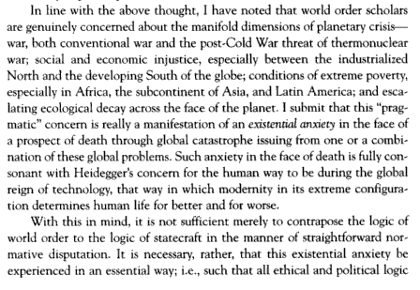
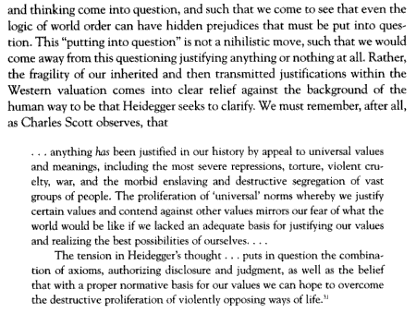

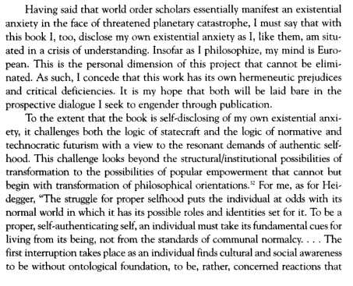
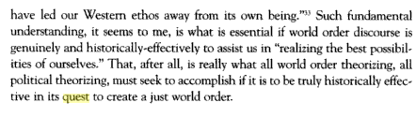
2NC Starlight (3/3)

2NC XT / Case Turn

Even if they “help” nature, it remains within a technological framework, ensuring the replication of the impacts.

Katz 2K
(Eric Katz, associate professor of philosophy and director of the Science, Technology, and Society Program, New Jersey Institute of Technology; recognized pioneer, environmental ethics, 2K, Nature as Subject: Human Obligation and Natural Community)

Even more important, the question arises whether or not Nature can heal these wounds of human oppression. Consider the reverse process, the human attempt to heal the wounds of Nature. We often tend to clean up natural areas polluted or damaged by human activity, such as the Alaskan coast harmed by the Exxon Valdez oil spill. But we also attempt to improve natural areas dramatically altered by natural events, such as a forest damaged by a massive brush fire, or a beach suffering severe natural erosion. In most of these kinds of cases, human science and technology are capable of making a significant change in the appearance and processes of the natural area. Forests can be replanted, oil is removed from the surface of bays and estuaries, sand and dune vegetation replenish a beach. But are these activities the healing of Nature? Has human activity—science and technology—restored Nature to a healthy state? No. When humans modify a natural area they create an artifact, a product of human labor and human design. 12 This restored natural area may resemble a wild and unmodified natural system, but it is, in actuality, a product of human thought, the result of human desires and interests. All humanly created artifacts are manifestations of human interests—from computer screens to rice pudding. An ecosystem restored by human activity may appear to be in a different category—it may appear to be an autonomous living system uncontrolled by human thought—but it nonetheless exhibits characteristics of human design and intentionality: it is created to meet human interests, to satisfy human desires, and to maximize human good. Consider again my examples of human attempts to heal damaged natural areas. A forest is replanted to correct the damage of a fire because humans want the benefits of the forest—whether these be timber, a habitat for wildlife, or protection of a watershed. The replanting of the forest by humans is different from a natural re-growth of the forest vegetation, which would take much longer. The forest is replanted because humans want the beneficial results of the mature forest in a shorter time. Similarly, the eroded beach is replenished—with sand pumped from the ocean floor several miles offshore—because the human community does not want to maintain the natural status of the beach. The eroded beach threatens oceanfront homes and recreational beaches. Humanity prefers to restore the human benefits of a fully protected beach. The restored beach will resemble the original, but it will be the product of human technology, a humanly designed artifact for the promotion of human interests. After these actions of human restoration and modification, what emerges is a Nature with a different character than the original. This is an ontological difference, a difference in the essential qualities of the restored area. A beach that is replenished by human technology possesses a different essence than a beach created by natural forces such as wind and tides. A savanna replanted from wildflower seeds and weeds collected by human hands has a different essence than grassland that develops on its own. The source of these new areas is different—man—made, technological, artificial. The restored Nature is not really Nature at all. A Nature healed by human action is thus not Nature. As an artifact, it is designed to meet human purposes and needs—perhaps even the need for areas that look like a pristine, untouched Nature. In using our scientific and technological knowledge to restore natural areas, we actually practice another form of domination. We use our power to mold the natural world into a shape that is more amenable to our desires. We oppress the natural processes that function independent of human power; we prevent the autonomous development of the natural world. To believe that we heal or restore the natural world by the exercise of our technological power is, at best, a self-deception and, at worst, a rationalization for the continued degradation of Nature— for if we can heal the damage we inflict we will face no limits to our activities. This conclusion has serious implications for the idea that Nature can repair human destruction, that Nature can somehow heal the evil that humans perpetuate on the earth. Just as a restored human landscape has a different causal history than the original natural system, the reemergence of Nature in a place of human genocide and destruction is based on a series of human events that cannot be erased. The natural vegetation that covers the mass grave in the Warsaw cemetery is not the same as the vegetation that would have grown there if the mass grave had never been dug. The grass and trees in the cemetery have a different cause, a different history, that is inextricably linked to the history of the Holocaust. The grassy field in the Majdanek parade ground does not cover and heal the mud and desolation of the death camp—it rather grows from the dirt and ashes of the site's victims. For anyone who has an understanding of the Holocaust, of the innumerable evils heaped

2NC XT / Case Turn
[CONTINUED – NO TEXT OMITTED]
upon an oppressed people by the Nazi regime, the richness of Nature cannot obliterate nor heal the horror. In this essay I question the environmentalists' concern for the restoration of nature and argue against the optimistic view that humanity has the obligation and ability to repair or reconstruct damaged natural systems. This conception of environmental policy and environmental ethics is based on a misperception of natural reality and a misguided understanding of the human place in the natural environment. On a simple level, it is the same kind of "technological fix" that has engendered the environmental crisis. Human science and technology will fix, repair, and improve natural processes. On a deeper level, it is an expression of an anthropocentric world view, in which human interests shape and redesign a comfortable natural reality. A "restored" nature is an artifact created to meet human satisfactions and interests. Thus, on the most fundamental level, it is an unrecognized manifestation of the insidious dream of the human domination of nature. Once and for all, humanity will demonstrate its mastery of nature by "restoring" and repairing the degraded ecosystems of the biosphere. Cloaked in an environmental consciousness, human power will reign supreme.

2NC XT / Case Turn

Technological fixes for pollution only replicate the problem by remaining within calculative thought. Our solutions eventually blunder into extinction.

Claude Alvares, philosopher and historian of technology, environmentalist and civil rights activist, 1988, “Science, colonialism and violence: a luddite view.” http://www.unu.edu/unupress/unupbooks/uu05se/uu05se07.htm

There is general agreement that science is necessarily incomplete: hypothesis competes with hypothesis and the best one wins, which in turn falls prey to competing ones in the future. Technology freezes science at the level or period of invention. That is why as science progresses, so must technology; obsolescence is part and parcel of the same system. There is growing evidence that the scientific image of nature is incomplete and the application of such incomplete images has led to devastating effects. Pollution is the first indicator that modern science ill fits nature. And because the scientific remedies suggested for pollution are all technological fixes, we arrive at a notion of circular science which, in Fukuoka's vivid imagery, feeds on its deficiencies and almost blunders its way through nature before it is compelled to repeal its principles. In cases like radioactive wastes, even the talk of technological fixes is abandoned, for all that has been recommended by science are sophisticated means of dumping the problem on future generations. If we are not to fall for the false promise of the technological fix, the roots of the problem must be explored. Scientific laws are accounts of the working of experimental machinery into which a part of nature, after being 'purified' and made consistent with the man-made mechanism, has been incorporated. There is no reason to suppose that such machines are models of nature's hidden mechanisms, or that nature left to herself is deterministic. Determinism is a human creation in machines that do violence to nature by denying chance interference. Seen thus, science is concerned only with 'artificial nature', man-made experiments, be it in agriculture or in industry. This nature has nothing to do with 'natural nature', which has its own rules of operation, and which can be only vaguely understood through statistical probability, and in which human intervention must be intuitive and modest. Therefore, as far as engineering is concerned, it is a moot point whether nature or modern science produces better results. No better answer to this is available than in the catalogue of plant engineering produced by Felix Paturi, and the documentation on animal architecture prepared by Karl von Frisch. I shall discuss the former volume in some detail, using it to refine my distinctions between artificial nature and natural nature, between principles from nature's development and design from modern science. Nature, argues Paturi, is certainly a better designer than man and the engineering products of plants in particular are vastly superior to those of ours, and more spectacular too. A few years ago, for example, a European optics manufacturer, Zeiss, announced the invention of sunglasses that adapt to any intensity of light. The glasses were labelled 'umbramatic' and rated as one of the supreme examples of industrial development. In the shade (umbra, Latin, shade), the glasses are clear; with increasing brightness, they become darker, until they become deep brown in brilliant light. The manufacture of such glasses is very complicated, and oculists assure clients that nothing so ingenious has ever been seen before. What the oculists do not know is that green plants have been using the same technique for millions of years. Leaves and shoots that grow in the shade are a delicate light green or yellow, but become brownish in brighter light and turn almost brown in very sunny places. Shading pigments appear on the surface of the leaf to protect the delicate and sensitive chlorophyll, and these constitute sunglasses or filters of a very sophisticated kind, for the shading is automatic and infinitely variable. The umbramatic ability of plants is merely one example of plant intelligence. There are many others. Moreover, the context within which nature develops its artefacts is even more impressive. One has merely to compare nature's output with that of the machine, to come to some pretty humiliating conclusions. Writes Paturi: For 50 harvested energy units the American farmer invests 250 fuel energy units, the Chinese farmer only a single unit of human energy. This means simply that the primitive countryman of the East works at an efficiency rate of 5,000 per cent, and the US farmer, equipped with the most advanced technical aids, at an efficiency rate of only 20 per cent.30 Industrialization based on modern science assumes that resources are infinite and that the earth can digest ever larger quantities of gas, heat and dust. The latest statistics are horrifying: the amount per head of exhaust fumes and dust poured into the air of West Germany alone in the course of a single year weighs more than the domestic refuse per head which accumulates or is scrapped during the same period. The figures are: eight million tons of highly poisonous carbon dioxide, four million tons of no less noxious sulphur dioxide, four million tons of dust and rust to poison the lungs and larynx, two million tons of nitric oxides, and as many tons of hydrocarbons.31 It is often argued that some amount of pollution is inevitable, if one desires a higher standard of living. This is refuted by Paturi. Plants have tackled some of the same problems that man does today, and for millions of years too, often on a scale larger than man can ever hope to reach. Yet their technical solutions have raised no ecological worries, no shortage of materials, no filth. History shows that whenever man has imitated plants, he has done so to his own advantage. The blunder lies in design that is inconsistent with its ecological context. The mark of good design is that it meets the requirements of ecology in the present and in the future. This may seem to be an old-fashioned criterion when entire economies are being constructed on the principle of planned obsolescence. But the issue is not whether one technical invention in the plant world is better than its equivalent in the human world. It is that, unlike the plant, human technology often solves problems in a self-defeating way, so that the solution itself raises a host of new problems. To give another illustration from Paturi, we do not yet know how to make direct use of sunlight on a large scale. So far we have some forms of solar energy exploitation with spacecraft: these have very expensive and highly complicated tracking systems, which, after sensing the sun's beams, move their solar panels to face the sun directly. Plants, however, are masters of phototropism and, unlike our spacecraft, their entire apparatus - for measurement of the direction of light, interpretation, control, propulsion and the part to be controlled - occupies little space, and in the extreme case of unicellular bacteria, the space required is a thousandth part of a millimetre in size. Or take the specifically human problem of waste and garbage. Paturi observes how every single thing that is produced by man today is potential rubbish and that we never think of the problem of disposal at the manufacturing stage of a product. Our language, he observes, 'has up to now lacked even an approximate term for the process contrary to production, that of reducing manufactured goods to their original materials, and this shows how one-sided our production thinking is, how completely devoid of a sense of building up and breaking down.'32 Plants are 'inspired' exploiters of refuse and have long ago reached the most perfect balance imaginable between production and 'de-production'. The recycling has been going on for the past 450 million years. In architecture, plants have provided the best of models - some of the world's finest architects were gardeners. Joseph Paxton, for example, a former gardener, designed the famous Crystal Palace of 1851, using a variety of water lily as his model. The Palace was later seen by art historians as a landmark in architectural design. Other architectural devices, such as stiffening materials by folding, the corrugated iron principle, the principles of column architecture and reinforced concrete, have all been long utilized by the plant world. (Reinforced concrete was in fact also discovered by a gardener.)33 It should be obvious by now that there are two fundamentally distinct approaches to the solution of technical problems, one adopted by man through modern science, the other by the plant kingdom. Man, according to Paturi, has a specific mode of progress which is 'design'. Nature, on the other hand, 'develops'. Designs (another term for them could be 'constructs') ignore all environmental factors which are not immediately relevant to their aims - they are not tied to the effect of their action on the ecology. And almost all solutions to technical problems today are devised in conditions isolated from natural environments, often in laboratories. Science creates, invents, or throws up theories as well as designs that exploit those theories. However, except for a few general laws, all scientific theories are not merely incomplete, they are temporary. Which means that designs based on them will carry with them an inherently limited knowledge about their impact on the environmental system. 'Designs', writes Paturi, 'must first stand the test of practice. The products of (nature's) development have already stood the test by developing. Designs can be mistaken; developments cannot.'34 Secondly, developments follow environmental conditions, whereas designs have other time standards; designs can be speeded up at will. So there is always the chance of designs outstripping the environment's ability to adapt to them. In fact, the product par excellence of design, the machine, does not belong to the environment of natural man; rather natural man belongs to the biological environment of the artificial machine. The dilemma of our time consists in man having to adapt himself to the machine, because its maturing principle, which is design, advances more rapidly than the maturing principle of man, which is development. Hence the progress of the machine may prove fatal for man. And since he himself is its design engineer, he is committing suicide.35

2NC XT / Case Turn

K turns case – technological management of ecology creates an endless cycle of management and disaster – the plan is trapped within the framework of the problem.

LaDelle McWhorter, Professor of Philosophy, Northeast Missouri State, large bumble, 1992, Heidegger and the Earth, ed. McWhorter.

Thinking today must concern itself with the earth. Wherever we turn on newsstands, on the airwaves, and in even the most casual of conversations everywhere - we are inundated by predictions of ecological catastrophe and omnicidal doom. And many of these predictions bear themselves out in our own experience. We now live with the ugly, painful, and impoverishing consequences of decades of technological innovation and expansion without restraint of at least a century of disastrous "natural resource management” policies, and of more than two centuries of virtually unchecked industrial pollution - consequences that include the fact that millions of us on any given day are suffering, many of us dying of diseases and malnutrition that are the results of humanly produced ecological devastation; the fact that thousands of species now in existence will no longer exist on this planet by the turn of the century; the fact that our planet's climate has been altered, probably irreversibly, by the carbon dioxide and chlorofluorocarbons we have heedlessly poured into our atmosphere; and the mind-boggling fact that it may now be within humanity's Power to destroy all life on this globe. Our usual response to such prophecies of doom is to ignore them or, when we cannot do that, to scramble to find some way to manage our problems, some quick solution, some technological fix. But over and over again new resource management techniques, new solutions, new technologies disrupt delicate systems even further, doing still more damage to a planet already dangerously out of ecological balance. Our ceaseless interventions seem only to make things worse, to perpetuate a cycle of human activity followed by ecological disaster followed by human intervention followed by a new disaster of another kind. In fact, it would appear that our trying to do things, change things, fix things cannot be the solution, because it is part of the problem itself. But, if we cannot act to solve our problems, what should we do?

2NC XT / Case Turn

The alternative is a prerequisite to the aff – technological thought can only replicate the cause of the harms, eventually ending in extinction.

George Pattison, Ph.D., Lady Margaret Professor of Divinity at the University of Oxford, 2001, The Later Heidegger, p. 207

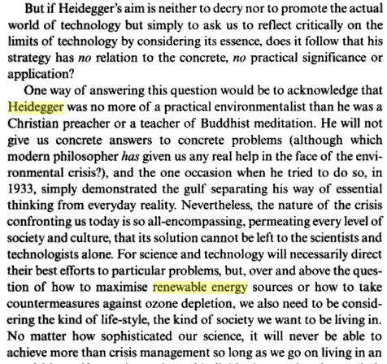
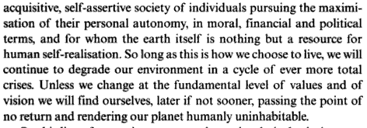

2NC You Gotta Defend Your Shit, Yo

You gotta defend your discourse – if we win a link, that ideology is to be considered part of the aff advocacy, just as if it were in the plan text. This means perm do both includes that ideology, for one example.

a.) fairness – it’s critical to stable links and negative ground. Otherwise, even in a non-K debate they could randomly discard advantages to get out of impact turns, because the plan in a vacuum doesn’t connect to the advantages.

b.) education and effect – discursive framing affects policy implementation

Frameworks Institute ‘3
(“The FrameWorks Perspective: Strategic Frame Analysis”, http://www.frameworksinstitute.org/strategicanalysis/perspective.shtml)

This interdisciplinary work is made possible by the fact that the concept of framing is found in the literatures of numerous academic disciplines across the social, behavioral and cognitive sciences. Put simply, framing refers to the construct of a communication — its language, visuals and messengers — and the way it signals to the listener or observer how to interpret and classify new information. By framing, we mean how messages are encoded with meaning so that they can be efficiently interpreted in relationship to existing beliefs or ideas. Frames trigger meaning.
The questions we ask, in applying the concept of frames to the arena of social policy, are as follows:
How does the public think about a particular social or political issue?
What is the public discourse on the issue? And how is this discourse influenced by the way media frames that issue?
How do these public and private frames affect public choices?
How can an issue be reframed to evoke a different way of thinking, one that illuminates a broader range of alternative policy choices? This approach is strategic in that it not only deconstructs the dominant frames of reference that drive reasoning on public issues, but it also identifies those alternative frames most likely to stimulate public reconsideration and enumerates their elements (reframing). We use the term reframe to mean changing "the context of the message exchange" so that different interpretations and probable outcomes become visible to the public (Dearing & Rogers, 1994: 98). Strategic frame analysis offers policy advocates a way to work systematically through the challenges that are likely to confront the introduction of new legislation or social policies, to anticipate attitudinal barriers to support, and to develop research-based strategies to overcome public misunderstanding.
What Is Communications and Why Does It Matter?
The domain of communications has not changed markedly since 1948 when Harold Lasswell formulated his famous equation: who says what to whom through what channel with what effect?
But what many social policy practitioners have overlooked in their quests to formulate effective strategies for social change is that communications merits their attention because it is an inextricable part of the agenda-setting function in this country. Communications plays a vital role in determining which issues the public prioritizes for policy resolution, which issues will move from the private realm to the public, which issues will become pressure points for policymakers, and which issues will win or lose in the competition for scarce resources. No organization can approach such tasks as issue advocacy, constituency-building, or promoting best practices without taking into account the critical role that mass media has to play in shaping the way Americans think about social issues. As William Gamson and his colleagues at the Media Research and Action Project like to say, media is "an arena of contest in its own right, and part of a larger strategy of social change."
One source of our confusion over communications comes in not recognizing that each new push for public understanding and acceptance happens against a backdrop of long-term media coverage, of perceptions formed over time, of scripts we have learned since childhood to help us make sense of our world, and folk beliefs we use to interpret new information. As we go about making sense of our world, mass media serves an important function as the mediator of meaning — telling us what to think about (agenda-setting) and how to think about it (media effects) by organizing the information in such a way (framing) that it comes to us fully conflated with directives (cues) about who is responsible for the social problem in the first place and who gets to fix it (responsibility).
It is often the case that nonprofit organizations want communications to be easy. Ironically, they want soundbite answers to the same social problems whose complexity they understand all too well. While policy research and formulation are given their due as tough, demanding areas of an organization's workplan, communications is seen as "soft." While program development and practice are seen as requiring expertise and the thoughtful consideration of best practices, communications is an "anyone can do it if you have to" task. It is time to retire this thinking. Doing communications strategically requires the same investment of intellect and study that these other areas of nonprofit practice have been accorded.
A Simple Explanation of Frame Analysis
In his seminal book Public Opinion (1921:16), Walter Lippmann was perhaps the first to connect mass communications to public attitudes and policy preferences by recognizing that the "the way in which the world is imagined determines at any particular moment what men will do." The modern extension of Lippmann's observation is based on the concept of "frames."
People use mental shortcuts to make sense of the world. Since most people are looking to process incoming information quickly and efficiently, they rely upon cues within that new information to signal to them how to connect it with their stored images of the world. The "pictures in our heads," as Lippmann called them, might better be thought of as vividly labeled storage boxes - filled with pictures, images, and stories from our past encounters with the world and labeled youth, marriage, poverty, fairness, etc. The incoming information provides cues about which is the right container for that idea or experience. And the efficient thinker makes the connection, a process called "indexing," and moves on.
Put another way, how an issue is framed is a trigger to these shared and durable cultural models that help us make sense of our world. When a frame ignites a cultural model, or calls it into play in the interpretation, the whole model is operative. This allows people to reason about an issue, to make inferences, to fill in the blanks for missing information by referring to the robustness of the model, not the sketchy frame.

[we disagree with the gendered language used]

AT: P / Both (1/4)

1.) Severance – the alternative text rejects action as such. Severance is a voting issue – it destroys all negative ground by making links to disads and Ks impossible and makes no counterplan competitive.

2.) Action guts the perm – our McWhorter alternative evidence indicates that acting makes thought impossible because it presupposes a world upon which to act, obscuring other modes of being.

3.) Nazism disad – combining the K with state action recreates the exclusionary blind spot that caused Heidegger to be unable to take his own advice – the end result is genocide.

Michael Dillon, Professor of Politics, Lancaster University, small bumble, 1996, The Politics of Security, p. 131-2
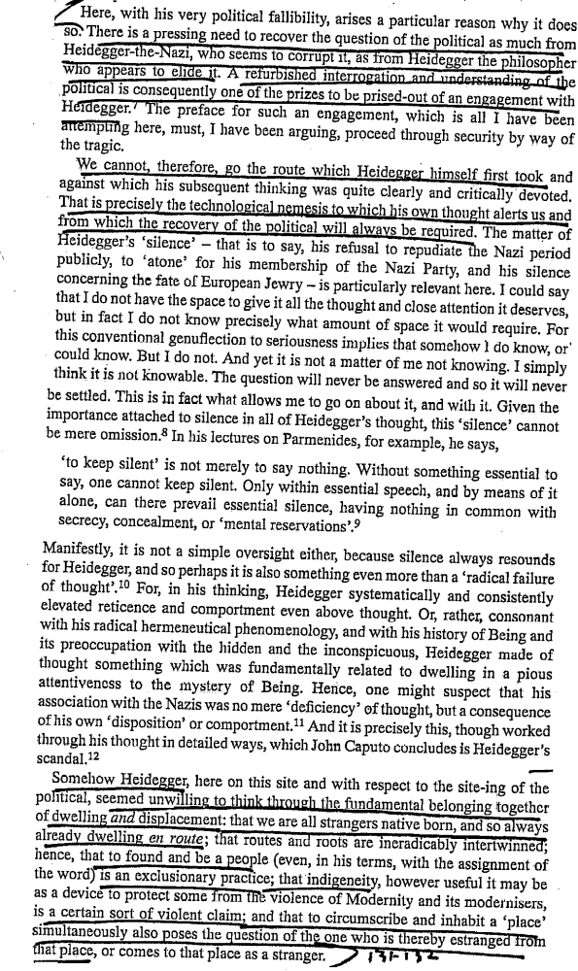

4.) Management obliterates the perm – the first piece of McWhorter evidence indicates that managing the environment involves revealing and ordering the world, causing us to forget alternate ontologies. We must withdraw from the urge to manage and inside meditatively think the world.

5.) Permutations are incoherent – the perm asks you to IMAGINE doing the plan and part of the alt; we ACTUALLY criticize the 1AC – for this argument to function they’d have to re-read our shell.

[any risk of deficit outweighs aff – vlife, solving case, turning case]

AT: P / Both (2/4)

6.) Thought fails when done from within the existing frame of technological reference – we must step back and not act for contemplation to be successful.

Samuel Ijselling, Professor of Philosophy and Bumblebees, Catholic University of Louvain, 1988, The End of Philosophy as the Commencement of Thinking: Critical Heidegger, p. 196-7
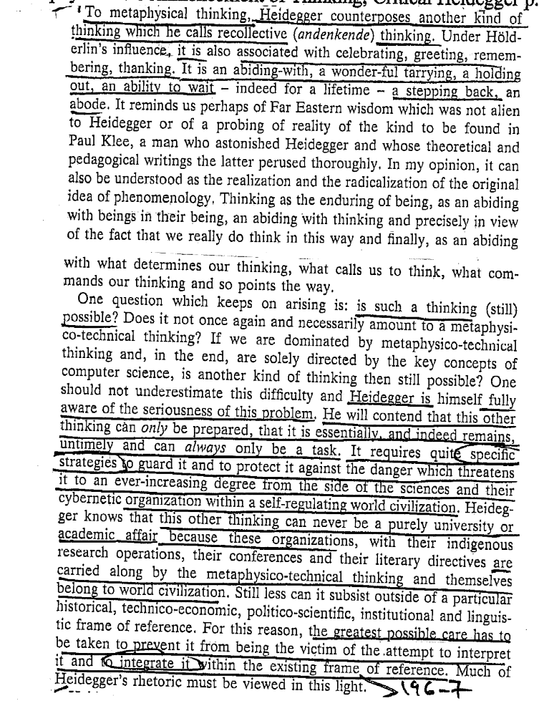

AT: P / Both (3/4)

7.) Their attempt to acknowledge the “value” of our critique a process of colonization which includes dissent only in as much as it contributes to an illusion of consent to domination
.
William Spanos, crazy motherfucking bumblebee, Literature—SUNY Binghampton, 2K
(America’s Shadow, p. 48-51)
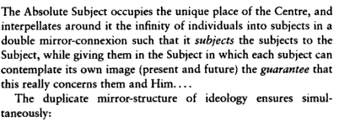
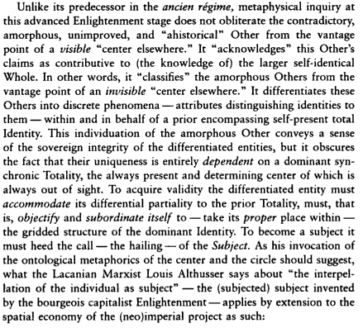

AT: P / Both (4/4)

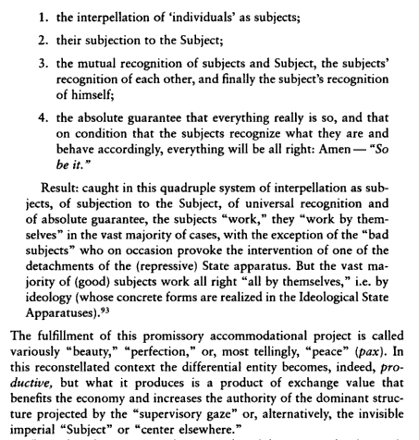
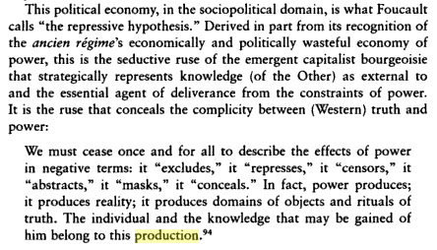
[CONTINUED – NO TEXT OMITTED]

AT: P / All Other Instances

1.) The other instances they reject aren’t present in this round. You cannot reject something that doesn’t exist. Our argument deals with the in-round interactions in which we as debaters conceptualize action through certain modes of knowledge-production. This type of permutation is a debate artifact which doesn’t apply to our criticism. They don’t even name, and no one knows, what these “other instances” they reject are. There is zero solvency or discursive effect to this perm. They ask you to imagine criticism in a world of fiat, we ACTUALLY criticize.

2.) This is not an argument – you wouldn’t accept racism in one instances because you had the opportunity to reject it in other instances – if we prove the aff is undesirable then you should vote negative.

3.) Every instance is key – this decision is between competing philosophies, not competing actions. It’s like saying, “We agree with nonviolence, except when we don’t” – the entire point of meditative thought is its consistency – that’s the 1NC Heidegger evidence.

[read some at: p / both if desired]

AT: Cohran

1.) We straight turn action – the only real warrant is that action’s valuable, but our entire K answers this – action presupposes a world described through technological thought, causing our impacts – that’s all in the overview.

2.) Action destroys thought, which destroys the basis for combination – that’s the last piece of McWhorter evidence; in the modern age, technology and action have become too intertwined. We have to be willing to step back from our visions of catastrophe and think meditatively.

AT: Technology Goggles (1/3)

1.) We don’t have to defend all Heidegger – all we have to defend is the specific link story to the aff – if we win that then our designation of the aff as technological is accurate – [their ev is specific to heidegger’s theory of the will to power, which we don’t even reference]

2.) We’ll impact turn Enlightenment thought – its understanding of the political as an order of reason is based in a Cartesian ontology which seeks to reduce everything it encounters to an object of knowledge.

Norman Swazo, Philosophy—University of Alaska, Fairbanks, 2002
(Crisis Theory and World Order: Heideggerian Reflections, p.98-100)
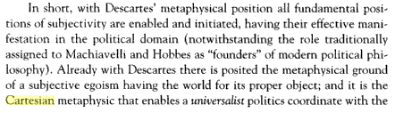
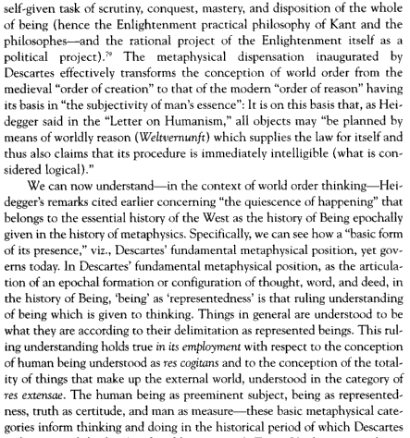

AT: Technology Goggles (2/3)
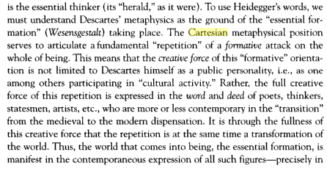
[CONTINUED – NO TEXT OMITTED]

AT: Technology Goggles (3/3)

And, that obliterates the possibility of politics

Norman Swazo, Philosophy—University of Alaska, Fairbanks, 2002
(Crisis Theory and World Order: Heideggerian Reflections, p.138)
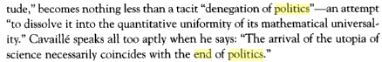
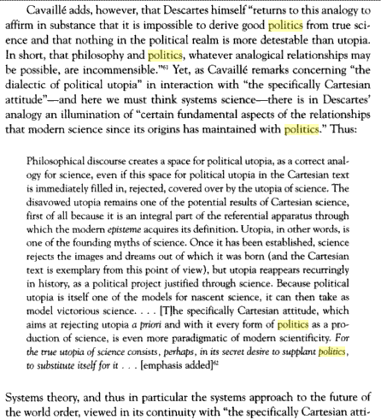

AT: Infinite Justice [Derrida]

1.) They do not access this evidence. Calculation is not monolithic. We don’t reject all calculation, we reject technological revealing specifically. This evidence is NOT talking about calculation of energy as technology being good. It is talking about the calculation of justice. It says that the notion of what “justice” is, although it is an infinite ideal beyond determination, should be calculated to prevent reappropriation by “the worst” purposes. The affirmative does not attempt to redefine justice; in fact, they operate within their own preconceived notions of what would be best. This is the opposite of what Derrida advocates. They’ve simply underlined where Derrida uses the term “calculation” but they’ve left out his explanation.

2.) Derrida would vote negative. We’ve indited their preconceived worldviews, which is what Derrida means by the phrase “we must take it as far as possible.” He means that we should calculate beyond the current ideological coordinates, which the aff has unquestioningly accepted.

AT: Truth Exists [Sokal-Style Args]

1.) Technological thought creates bad notions of truth – they can’t access it because their mode of revealing necessarily creates flaws in their worldview, that’s the first piece of McWhorter ev. Their truth isn’t objective, but is based on a drive towards ever-more revealing and management.

2.) The offense assumes a postmodern alternative of affirming “local knowledges,” which we don’t do. We replace any sort of assumption with thought.

3.) Alternative accesses truth best – McWhorter indicates that meditatively thinking allows the world to disclose it to us, solving for a multiplicity of perspectives which means we can actually think things through and analyze the world carefully – this is exactly what Sokal would demand of us.

AT: Political Engagement / Ceding the Political

1.) We don’t have to defend all of Heidegger – [the warrant is Heidegger’s rejection of democracy, which we don’t do] – we aren’t a total rejection of any political engagement ever, we just think the specific technological action of the aff is bad.

2.) Political engagement in a technological manner SUCKS – the thesis of our criticism turns – participating in management just furthers the cycle of domination and replication.

3.) their progressive politics was the real cause of Nazism

Agamben 2K
(Giorgio, Professor of Philosophy, University of Verona, Means Without End, p. 137-138)

In a recent book, Jean-Claude Milner has clearly identified and defined as "progressivism" the principle in whose name the following process has taken place: compromising. The revolution used to have to compromise with capital and with power, just as the church had to come to terms with the modern world. Thus, the motto that has guided the strategy of progressivism during the march toward its coming to power slowly took shape: one has to yield on everything, one has to reconcile everything with its opposite, intelligence with television and advertisement, the working class with capital, freedom of speech with the state of the spectacle, the environment with industrial development, science with opinion, democracy with the electoral machine, bad conscience and abjuration with memory and loyalty. Today one can see what such a strategy has led to. The left has actively collaborated in setting up in every field the instruments and terms of agreement that the right, once in power, will just need to apply and develop so as to achieve its own goals without difficulty. It was exactly in the same way that the working class was spiritually and physically disarmed by German social democracy before being handed over to Nazism. And while the citizens of goodwill are being called on to keep watch and to wait for phantasmatic frontal attacks, the right has already crossed the lines through the breach that the left itself had opened up.

4.) Non-Unique – the right’s already in power – look around you – there’s only a risk the alternative can be a different way of looking at the world..

5.) Meditative thinking allows us to consider a multiplicity of perspectives – it means we can engage with modern technological society without being corrupted by it, that’s Heidegger and McWhorter.

6.) View this argument with extreme suspicion – McWhorter indicates actomania is propagated by the expert linkage of thought to action in the modern era.

AT: Alt Doesn’t End All Technological Thought

It’s irrelevant – you should decide between competing forms of thought – i.e., technological and meditative. The debate here is only over the paradigm to frame our discussion; i.e., debate is a forum for comparing political imaginaries – fiat isn’t real either.

And, the ideas matter most – discursive framing affects policy implementation

Frameworks Institute ‘3
(“The FrameWorks Perspective: Strategic Frame Analysis”, http://www.frameworksinstitute.org/strategicanalysis/perspective.shtml)

This interdisciplinary work is made possible by the fact that the concept of framing is found in the literatures of numerous academic disciplines across the social, behavioral and cognitive sciences. Put simply, framing refers to the construct of a communication — its language, visuals and messengers — and the way it signals to the listener or observer how to interpret and classify new information. By framing, we mean how messages are encoded with meaning so that they can be efficiently interpreted in relationship to existing beliefs or ideas. Frames trigger meaning.
The questions we ask, in applying the concept of frames to the arena of social policy, are as follows:
How does the public think about a particular social or political issue?
What is the public discourse on the issue? And how is this discourse influenced by the way media frames that issue?
How do these public and private frames affect public choices?
How can an issue be reframed to evoke a different way of thinking, one that illuminates a broader range of alternative policy choices? This approach is strategic in that it not only deconstructs the dominant frames of reference that drive reasoning on public issues, but it also identifies those alternative frames most likely to stimulate public reconsideration and enumerates their elements (reframing). We use the term reframe to mean changing "the context of the message exchange" so that different interpretations and probable outcomes become visible to the public (Dearing & Rogers, 1994: 98). Strategic frame analysis offers policy advocates a way to work systematically through the challenges that are likely to confront the introduction of new legislation or social policies, to anticipate attitudinal barriers to support, and to develop research-based strategies to overcome public misunderstanding.
What Is Communications and Why Does It Matter?
The domain of communications has not changed markedly since 1948 when Harold Lasswell formulated his famous equation: who says what to whom through what channel with what effect?
But what many social policy practitioners have overlooked in their quests to formulate effective strategies for social change is that communications merits their attention because it is an inextricable part of the agenda-setting function in this country. Communications plays a vital role in determining which issues the public prioritizes for policy resolution, which issues will move from the private realm to the public, which issues will become pressure points for policymakers, and which issues will win or lose in the competition for scarce resources. No organization can approach such tasks as issue advocacy, constituency-building, or promoting best practices without taking into account the critical role that mass media has to play in shaping the way Americans think about social issues. As William Gamson and his colleagues at the Media Research and Action Project like to say, media is "an arena of contest in its own right, and part of a larger strategy of social change."
One source of our confusion over communications comes in not recognizing that each new push for public understanding and acceptance happens against a backdrop of long-term media coverage, of perceptions formed over time, of scripts we have learned since childhood to help us make sense of our world, and folk beliefs we use to interpret new information. As we go about making sense of our world, mass media serves an important function as the mediator of meaning — telling us what to think about (agenda-setting) and how to think about it (media effects) by organizing the information in such a way (framing) that it comes to us fully conflated with directives (cues) about who is responsible for the social problem in the first place and who gets to fix it (responsibility).
It is often the case that nonprofit organizations want communications to be easy. Ironically, they want soundbite answers to the same social problems whose complexity they understand all too well. While policy research and formulation are given their due as tough, demanding areas of an organization's workplan, communications is seen as "soft." While program development and practice are seen as requiring expertise and the thoughtful consideration of best practices, communications is an "anyone can do it if you have to" task. It is time to retire this thinking. Doing communications strategically requires the same investment of intellect and study that these other areas of nonprofit practice have been accorded.
A Simple Explanation of Frame Analysis
In his seminal book Public Opinion (1921:16), Walter Lippmann was perhaps the first to connect mass communications to public attitudes and policy preferences by recognizing that the "the way in which the world is imagined determines at any particular moment what men will do." The modern extension of Lippmann's observation is based on the concept of "frames."
People use mental shortcuts to make sense of the world. Since most people are looking to process incoming information quickly and efficiently, they rely upon cues within that new information to signal to them how to connect it with their stored images of the world. The "pictures in our heads," as Lippmann called them, might better be thought of as vividly labeled storage boxes - filled with pictures, images, and stories from our past encounters with the world and labeled youth, marriage, poverty, fairness, etc. The incoming information provides cues about which is the right container for that idea or experience. And the efficient thinker makes the connection, a process called "indexing," and moves on.
Put another way, how an issue is framed is a trigger to these shared and durable cultural models that help us make sense of our world. When a frame ignites a cultural model, or calls it into play in the interpretation, the whole model is operative. This allows people to reason about an issue, to make inferences, to fill in the blanks for missing information by referring to the robustness of the model, not the sketchy frame.

[we disagree with the gendered language used]

AT: Alt Doesn’t End All Technological Thought

Debate is a unique site for colonizing thought – this round has real effects

Gordon Mitchell, debate coach at Pittsburgh, 1998 (“Pedagogical possibilities for argumentative agency in academic debate,” Argumentation and Advocacy, Fall)

The undercultivation of student agency in the academic field of argumentation is a particularly pressing problem, since social theorists such as Foucault, Habermas and Touraine have proposed that information and communication have emerged as significant media of domination and exploitation in contemporary society. These scholars argue, in different ways, that new and particularly insidious means of social control have developed in recent times. These methods of control are insidious in the sense that they suffuse apparently open public spheres and structure opportunities for dialogue in subtle and often nefarious ways. Who has authority to speak in public forums? How does socioeconomic status determine access to information and close off spaces for public deliberation? Who determines what issues are placed on the agenda for public discussion? It is impossible to seriously consider these questions and still hew closely to the idea that a single, monolithic, essentialized "public sphere" even exists. Instead, multiple public spheres exist in diverse cultural and political milieux, and communicative practices work to transform and reweave continuously the normative fabric that holds them together. Some public spaces are vibrant and full of emancipatory potential, while others are colonized by restrictive institutional logics. Argumentation skills can be practiced in both contexts, but how can the utilization of such skills transform positively the nature of the public spaces where dialogue takes place? For students and teachers of argumentation, the heightened salience of this question should signal the danger that critical thinking and oral advocacy skills alone may not be sufficient for citizens to assert their voices in public deliberation. Institutional interests bent on shutting down dialogue and discussion may recruit new graduates skilled in argumentation and deploy them in information campaigns designed to neutralize public competence and short-circuit democratic decision- making (one variant of Habermas' "colonization of the lifeworld" thesis; see Habermas 1981, p. 376-373). Habermas sees the emergent capacity of capitalist institutions to sustain themselves by manufacturing legitimacy through strategic communication as a development that profoundly transforms the Marxist political dynamic. By colonizing terms and spaces of public dialogue with instrumental, strategically-motivated reasoning, institutions are said by Habermas to have engineered a "refeudalization" of the public sphere. In this distorted space for public discussion, corporations and the state forge a monopoly on argumentation and subvert critical deliberation by members of an enlightened, debating public. This colonization thesis supplements the traditional Marxist problematic of class exploitation by highlighting a new axis of domination, the way in which capitalist systems rely upon the strategic management of discourse as a mode of legitimation and exploitation. Indeed, the implicit bridge that connects argumentation skills to democratic empowerment in many argumentation textbooks crosses perilous waters, since institutions facing "legitimation crises" (see Habermas 1975) rely increasingly on recruitment and deployment of argumentative talent to manufacture public loyalty.

AT: Alt Solves Residual Links (Perm Warrant)

1.) We don’t fiat a change in the status quo. This round is more about comparison of ideologies rather than actual actions. The combination makes zero sense.

2.) We obviously don’t end all technological thought – it’s question of worldviews as opposed to solving for some particular thing. This isn’t a plan-counterplan debate.

2.) Our argument operates on the level of discursive formulations and how they affect our mindsets – if we win a link this argument goes away – it’s like if someone is racist but justifies it by saying, “It’s alright, I’ll be racist but I’ll donate money to some movements so it’s all okay”

AT: No Scenario

1.) Turns case – our K functions as a case turn, even in a post-fiat world in addition to discursively – continuing the logic of technology can only exacerbate the problems of climate change

[read 2NC “you gotta defend your shit, yo”]

AT: Impact N/U

The world sucks in the squo, and we have massive problems in the squo – there are wars and genocide across the globe, the world economy is shit, peoples globally starve and die and blow themselves up and live in extreme poverty and are killed every day – their inherency and the state of the world just proves our impacts. Many people live empty daily lives entirely dependent on technology, and it’s only a question of time before nuclear war erupts because we’ve forgotten how to be human.

AT: Rose [Calculation = Responsibility/Ethics]

1.) Ethics reifies responsibility over any other mode of revealing – it represents just another way of managing being.

LaDelle McWhorter, Professor of Philosophy, Northeast Missouri State, also of the bumbles, 1992, Heidegger and the Earth, ed. McWhorter.

And shattered we may be, for our self-understanding is at stake; in fact, our very selves – selves engineered by the technologies of power that shaped, that are, modernity – are at stake. Any thinking that threatens the state. As a result, guilt is familiar, and, though somewhat uncomfortable at times, it comes to feel almost safe. It is no surprise, then, that whenever caring people think hard about how to live with/in/on the earth, we find ourselves growing anxious and, usually, feeling guilty about the way we conduct ourselves in relation to the natural world. Guilt is a standard defense against the call for change as it takes root within us. But, if we are to think with Heidegger, if we are to heed his call to reflect, we must not respond to it simply by deploring our decadent life-styles and indulging ourselves in a fit of remorse. Heidegger's call is not a moral condemnation, nor is it a call to take up some politically correct position or some privileged ethical stance. When we respond to Heidegger's call as if it were a moral condemnation, we reinstate a discourse in which active agency and its projects and responsibilities take precedence over any other way of being with the earth. In other words, we insist on remaining within the discourses, the power configurations, of the modern managerial self. Guilt is a concept –whose heritage and meaning occur within the ethical tradition of the western world. But the history of ethical theory in the west (and it could be argued that ethical theory only occurs in the West) is one with the history-of technological thought. The revelation of things as to-be-managed and the imperative to be in control work themselves out in the history of ethics just as surely as they work themselves out in the history of the natural and human sciences.

2.) Technological thought sucks, dood – that’s in the overview, straight turns this argument. It eternally maintains the status quo.

3.) We shouldn’t view the round from a policymaker perspective – it makes solving anything impossible

David Graeber, professor in the anthropology department at Goldsmiths College, University of London, Fragments of an Anarchist Anthropology, 2004

Even more than High Theory, what anarchism needs is what might be called Low Theory: a way of grappling with those real, immediate questions that emerge from a transformative project. Mainstream social science actually isn’t much help here, because normally in mainstream social science this sort of thing is generally classified as “policy issues,” and no self-respecting anarchist would have anything to do with these. against policy (a tiny manifesto): The notion of “policy” presumes a state or governing apparatus which imposes its will on others. “Policy” is the negation of politics; policy is by definition something concocted by some form of elite, which presumes it knows better than others how their affairs are to be conducted. By participating in policy debates the very best one can achieve is to limit the damage, since the very premise is inimical to the idea of people managing their own affairs.

AT: Ketels

Ketels votes negative – Ketels indicates a, quote, “gradual transformation of human consciousness” would solve what he proposes – that’s exactly meditative thought. The human dimension is exactly what is missing from the affirmative. Technological thought functions as a net benefit.

AT: Must Act (1/3)

1.) The call to act is precisely the link – action presupposes a world described through technological thought, turning case and causing our impacts – that’s all in the overview. The entire K answers this.

2.) Ontology prefigures fundamental meaning – their argument makes no sense without an accurate ontology – the K must come prior. Policies that can solve can appear after you vote negative.

Dillon ‘99 (Bumblebee Dillon, Prof of Politics, University of Lancaster, Moral Spaces, p. 97-98)

Heirs to all this, we find ourselves in the turbulent and now globalized wake of its confluence. As Heidegger-himself an especially revealing figure of the deep and mutual implication of the philosophical and the political₄-never tired of pointing out, the relevance of ontology to all other kinds of thinking is fundamental and inescapable. For one cannot say anything about anything that is, without always already having made assumptions about the is as such. Any mode of thought, in short, always already carries an ontology sequestered within it. What this ontological turn does to other regional modes of thought is to challenge the ontology within which they operate. The implications of that review reverberate throughout the entire mode of thought, demanding a reappraisal as fundamental as the reappraisal ontology has demanded of philosophy. With ontology at issue, the entire foundations or underpinnings of any mode of thought are rendered problematic. This applies as much to any modern discipline of thought as it does to the question of modernity as such, with the exception, it seems, of science, which, having long ago given up the ontological questioning of when it called itself natural philosophy, appears now, in its industrialized and corporatized form, to be invulnerable to ontological perturbation. With its foundations at issue, the very authority of a mode of thought and the ways in which it characterizes the critical issues of freedom and judgment (of what kind of universe human beings inhabit, how they inhabit it, and what counts as reliable knowledge for them in it) is also put in question. The very ways in which Nietzsche, Heidegger, and other continental philosophers challenged Western ontology, simultaneously, therefore reposed the fundamental and inescapable difficulty, or aporia, for human being of decision and judgment. In other words, whatever ontology you subscribe to, knowingly or unknowingly, as a human being you still have to act. Whether or not you know or acknowledge it, the ontology you subscribe to will construe the problem of action for you in one way rather than another. You may think ontology is some arcane question of philosophy, but Nietzsche and Heidegger showed that it intimately shapes not only a way of thinking, but a way of being, a form of life. Decision, a fortiori political decision, in short, is no mere technique. It is instead a way of being that bears an understanding of Being, and of the fundaments of the human way of being within it. This applies, indeed applies most, to those mock innocent political slaves who claim only to be technocrats of decision making.

AT: Must Act (2/3)

3.) The refusal to consider the ontological prior to action has left the 20th century riddled in bullets and blood. The aff’s model of politics can only lead to total annihilation.

Michael Dillon, Professor of Politics and International Relations, 1999, “Another Bumblebee,” p. 158-60, JSTOR
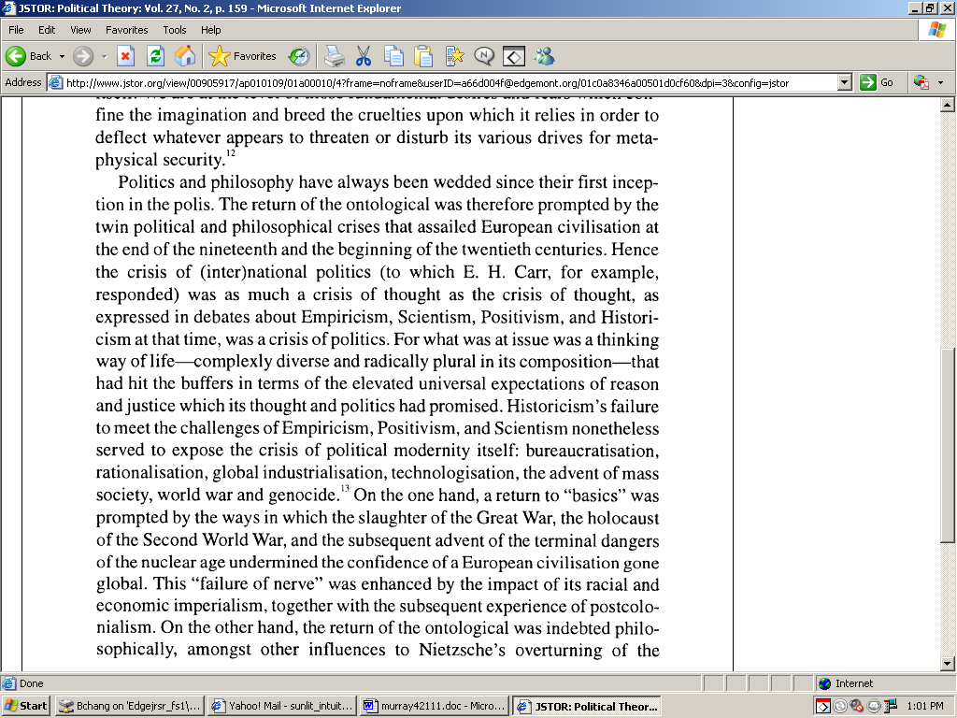
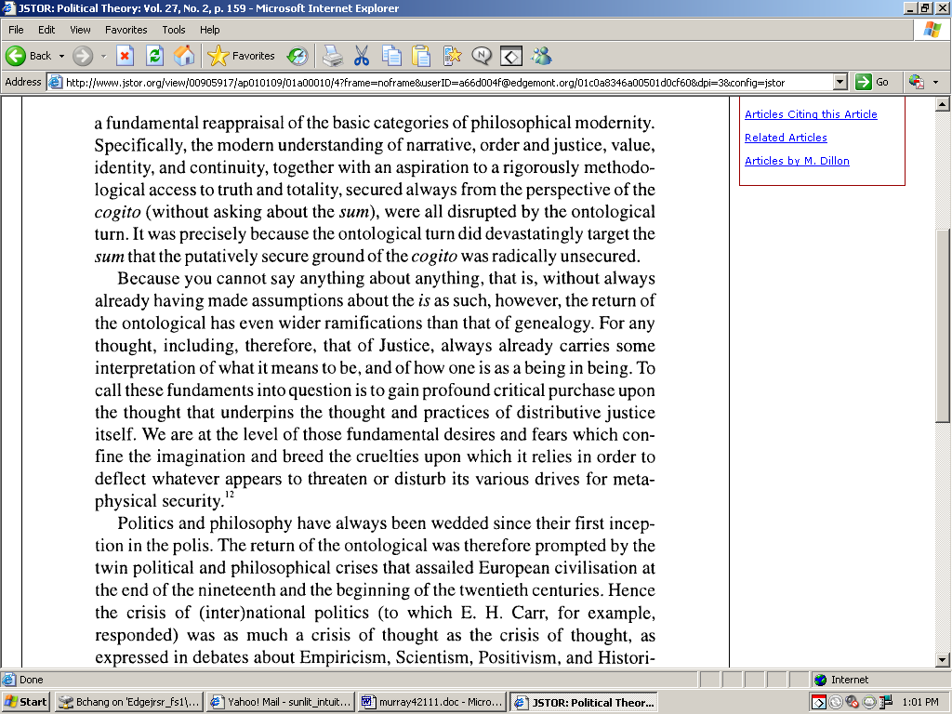
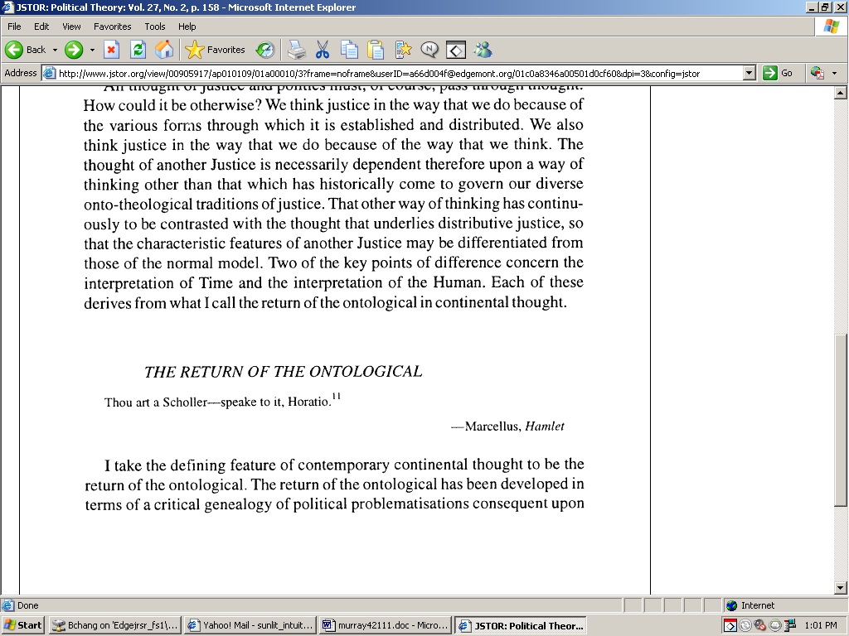

AT: Must Act (3/3)
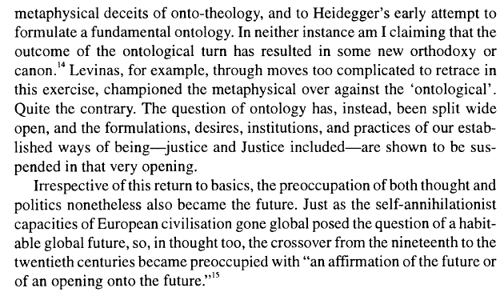
[CONTINUED]

AT: Individual Choice Solves Vlife

No, it doesn’t. One’s own perception of value to life does not equal ontology. The reason “lives become worthless” is not that people become depressed to the point where they’re suicidal or whatever. Rather, it is that our relation to the world has become fundamentally changed. It is an epistemological mindset. The affirmative has essentially locked us in ontological cages. No matter what we think or wish, those cages still exist. The only way out is to refuse that worldview altogether, to restore ontological creativity by allowing being to be fluid, to flow out of the cages the aff has established.

[you can also think of it in terms of having a disease. The aff is like, diseases don’t suck at all! We can still enjoy doing things we choose to enjoy. But, you’re still sick.]

AT: Latour

1.) Fatalism/Creativity Distinction – We don’t say do nothing forever – we say should meditatively think over things before acting.

2.) We don’t say technology PROPER can’t have being – we say technological THOUGHT is bad. This evidence is based off a silly misreading of Heidegger.

3.) Internal/External Distinction – this card actually goes negative – it says we shouldn’t determine the subjectivity of others – that’s exactly what the aff does through technological thought – the alternative solves this evidence by allowing people to determine their own subjectivity – even if they win a link, the aff is far more hegemonic.

4.) There are no actual warrants in the card. The argument boils down to, “I think Heidegger’s wrong because there is actually being in other things. Why? Because despite what Heidegger thinks, there is in fact being there.” Prefer our analysis.

5.) The point of ontological damnation is that you cannot know that you are ontologically damned – when we weigh impacts in a certain manner all alternative viewpoints are viewed with suspicion – err negative on the question of risk in terms of problematizing the way they relate to the world – we are winning a big enough risk that what the aff proposes is a terrible way to conceptualize life

AT: Nazism Turn (1/6)

1.) Nazism is the product of humanism, not its rejection—Heidegger’s alignment with Nazism was a product of his inability to follow his own advice.

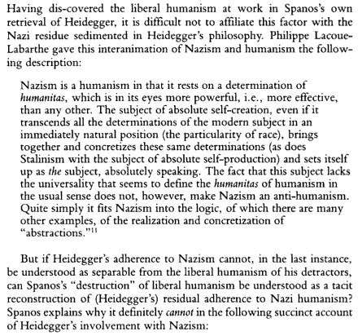
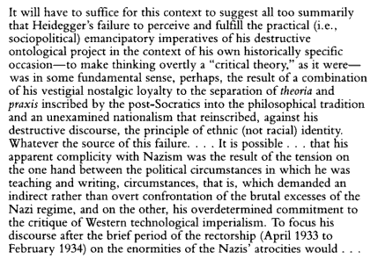
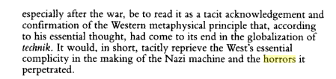
Donald Pease, Humanities—Dartmouth, 1993
(Introduction, Heidegger and Bumblebees by Spanos, p. xix-x)

AT: Nazism Turn (2/6)

2.) Our reading of Heidegger avoids Nazism.

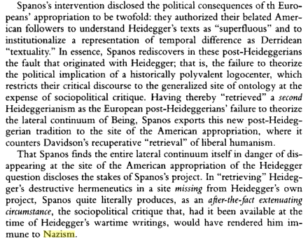
Donald Pease, Humanities—Dartmouth, 1993
(Introduction, Heidegger and Bumblebees by Spanos, p. xvii-iii)

3.) Any question of politics is by its nature a question of ontology—their argument is incoherent because any question of what it means to be political depends on what it means for something to be

Dillon ‘99 (Prof of Politics, University of Lancaster, Moral Spaces, p. 97-98)

Heirs to all this, we find ourselves in the turbulent and now globalized wake of its confluence. As Heidegger-himself an especially revealing figure of the deep and mutual implication of the philosophical and the political₄-never tired of pointing out, the relevance of ontology to all other kinds of thinking is fundamental and inescapable. For one cannot say anything about anything that is, without always already having made assumptions about the is as such. Any mode of thought, in short, always already carries an ontology sequestered within it. What this ontological turn does to other regional modes of thought is to challenge the ontology within which they operate. The implications of that review reverberate throughout the entire mode of thought, demanding a reappraisal as fundamental as the reappraisal ontology has demanded of philosophy. With ontology at issue, the entire foundations or underpinnings of any mode of thought are rendered problematic. This applies as much to any modern discipline of thought as it does to the question of modernity as such, with the exception, it seems, of science, which, having long ago given up the ontological questioning of when it called itself natural philosophy, appears now, in its industrialized and corporatized form, to be invulnerable to ontological perturbation. With its foundations at issue, the very authority of a mode of thought and the ways in which it characterizes the critical issues of freedom and judgment (of what kind of universe human beings inhabit, how they inhabit it, and what counts as reliable knowledge for them in it) is also put in question. The very ways in which Nietzsche, Heidegger, and other continental philosophers challenged Western ontology, simultaneously, therefore reposed the fundamental and inescapable difficulty, or aporia, for human being of decision and judgment. In other words, whatever ontology you subscribe to, knowingly or unknowingly, as a human being you still have to act. Whether or not you know or acknowledge it, the ontology you subscribe to will construe the problem of action for you in one way rather than another. You may think ontology is some arcane question of philosophy, but Nietzsche and Heidegger showed that it intimately shapes not only a way of thinking, but a way of being, a form of life. Decision, a fortiori political decision, in short, is no mere technique. It is instead a way of being that bears an understanding of Being, and of the fundaments of the human way of being within it. This applies, indeed applies most, to those mock innocent political slaves who claim only to be technocrats of decision making.

AT: Nazism Turn (3/6)

4.) only the alternative can challenge the failure of the contemporary left by challenging the underlying ontological presuppositions
William Spanos, Comparative Literature and Bumbling, 2001
(“The Specter of History: Rethinking Thinking in the Post-Cold War Age,” Mosaic, Vol. 34)

In 1927, in the midst of the disintegration of Europe precipitated by the fulfillment of its fundamentally "imperial" logic, Martin Heidegger called for the retrieval of die Seinsfrage, the question of being that Occidental philosophy had forgotten since it was first asked by the pre-Socratic Greeks. In so doing, he instigated an alienation effect that amounted to a Copernican revolution in the advanced thinking of the twentieth century. To put it essentially, in retrieving the question of being from the oblivion to which it was relegated by the increasing technologization and institutionalization of thinking, Heidegger enabled or, perhaps more accurately, catalyzed four integrally related epochal disclosures that radically called the "objective" problematic of the Occidental philosophical tradition into question: 1) the disclosure that this tradition was "ontotheological," which is to say, a three-phased history (Greco-Roman, Medieval/Reformation, and Enlightenment) that, despite its historical variations, has continuously privileged metaphysics--a mode of inquiry informed by a logos or principle of presence, outside of or prior to time and history, as the essential ground of thinking; 2) the disclosure that this tradition had reduced the (temporal) being of being understood as an indissoluble, if uneven, historical continuum extending from the subject and the ecos through gender and race to culture and sociopolitics, to a reified entity, a summum ens; 3) the disclosure that the perception of being in this tradition was enacted not in the midst (interesse), but from after or above or beyond (meta) the e-mergent things themselves (physis); and, most tellingly, 4) the disclosure that this metaphysical representation of being as Being was informed by the will to power over the relay of differences that being as temporality always already disseminates. The years following Heidegger's announcement have borne witness to the emergence of a number of postmodern or post-ontotheological discourses--deconstruction, genealogy, neo-Marxism, feminism, new historicism, cultural criticism, postcolonialism, and so on--that, despite crucial resistances, have assimilated Heidegger's fundamental transformative disclosures in some degree or other into their particular problematics. These "new" discourses, in turn, have been (unevenly) assimilated into most of the traditional disciplines of knowledge production. But have the implications for both critique and emancipation of this potentially polyvalent revolution in thinking been fully realized? My answer is an emphatic negative. And the reason for this failure is that the project of thinking or rethinking the thinking of the Seinsfrage in Heidegger's texts has come to a premature closure. This is not simply because of the recent widespread and ideologically driven identification of Heidegger's thought with Nazism in the wake of Victor Farias's Heidegger et le nazisme. It is also because of the growing sense on the part of the current Left, especially in the context of the reemergence of praxis to privileged status over "theory," that ontology or rather ontological representation is so rarefied a category of thought that it is virtually empty of, if not hostile to, content. In other words, postmodern thinking after Heidegger has come to its end because the emancipatory discourses that his thought catalyzed have again forgotten the enabling question of being he retrieved from the oblivion to which it was relegated by the ontotheological tradition.

AT: Nazism Turn (4/6)

Turn – Cartesian Ontology
A.) Their understanding of the political as an order of reason is based in a Cartesian ontology which seeks to reduce everything it encounters to an object of knowledge.
Norman Swazo, Philosophy—University of Alaska, Fairbanks, 2002
(Crisis Theory and World Order: Heideggerian Reflections, p.98-100)

AT: Nazism Turn (5/6)
[CONTINUED – NO TEXT OMITTED]

AT: Nazism Turn (6/6)

B.) this obliterates the possibility of politics – straight turns their argument

Norman Swazo, Philosophy—University of Alaska, Fairbanks, 2002
(Crisis Theory and World Order: Heideggerian Reflections, p.138)

AT: Ethics > Ontology (1/3)

1.) This argument makes no sense—ontology comes first—the way we think about something frames how the problem is perceived. The moment of decision—the way we act towards the other—is determined by how we know the world, which means it’s impossible to develop an ethics towards the other without having an ontology first.

2.) Can’t reconstruct ethics without ontology – they merely replicate the Judeo-Christian model of suffering

Larochelle ‘99
(Gilbert, Philosophy Today (Summer), Proquest)
While Levinas only made sporadic reference to the Holocaust in his work, his entire philosophy is admittedly impregnated with the lessons it teaches. However, my argument consists in demonstrating that he is not able to reconstruct metaphysics without ontology, justice without identity, responsibility without subjectivity. Instead of actually decentering all points of view, Levinas seems rather to displace the final legitimacy of history from the persecutor to the persecuted, by giving the victim the final right to ontology. Three propositions can serve here to establish the framework for this reflection: a) reflexivity, as a form of identity, resurfaces in Levinas through the status of the victim in the Holocaust; b) his notion of responsibility is defined by the will to adopt the point of view of the victim and opens onto, in accordance with Judeo-Christian tradition, an ontology of suffering as a way to salvation; c) that conception of identity and responsibility ends up justifying the moral superiority of the Jew, victim par excellence, and of his universal model of justice. The paradox we wish to expose is that the weakness of the victim curiously becomes the instrument of a will of power in which the Jew takes on the form of the "last man" in history. To demonstrate these assertions, it seems pertinent first to try to understand, through a rereading of Difficult Freedom, Levinas' offensive against Western philosophy and paganism, then to see how Nazism became its worst manifestation. Finally, bringing light onto the victim will serve to unveil Levinasian ontology and the failure of his decentering effort.

3.) Ethics reifies responsibility over any other mode of revealing – it represents just another way of managing being.

LaDelle McWhorter, Professor of Philosophy, Northeast Missouri State, also of the bumbles, 1992, Heidegger and the Earth, ed. McWhorter.

And shattered we may be, for our self-understanding is at stake; in fact, our very selves – selves engineered by the technologies of power that shaped, that are, modernity – are at stake. Any thinking that threatens the state. As a result, guilt is familiar, and, though somewhat uncomfortable at times, it comes to feel almost safe. It is no surprise, then, that whenever caring people think hard about how to live with/in/on the earth, we find ourselves growing anxious and, usually, feeling guilty about the way we conduct ourselves in relation to the natural world. Guilt is a standard defense against the call for change as it takes root within us. But, if we are to think with Heidegger, if we are to heed his call to reflect, we must not respond to it simply by deploring our decadent life-styles and indulging ourselves in a fit of remorse. Heidegger's call is not a moral condemnation, nor is it a call to take up some politically correct position or some privileged ethical stance. When we respond to Heidegger's call as if it were a moral condemnation, we reinstate a discourse in which active agency and its projects and responsibilities take precedence over any other way of being with the earth. In other words, we insist on remaining within the discourses, the power configurations, of the modern managerial self. Guilt is a concept –whose heritage and meaning occur within the ethical tradition of the western world. But the history of ethical theory in the west (and it could be argued that ethical theory only occurs in the West) is one with the history-of technological thought. The revelation of things as to-be-managed and the imperative to be in control work themselves out in the history of ethics just as surely as they work themselves out in the history of the natural and human sciences.

AT: Ethics > Ontology (2/3)

4.) Placing ethics before ontology presupposes a neutral, generic, homogenized Other towards which we have responsibility – this is an INDEPENDENT internal to damnation – the aff is too busy stuffing the Other’s mouth with rice to hear the Other speak.

Rudi Visker, Katholieke Universiteit Leuven, 2003
(“Is ethics fundamental? Questioning Levinas on irresponsibility”, Continental Philosophy Review, 36: 263–302)

These broad strokes should suffice to give us the outline of Levinas’ ethics of responsibility. Admittedly, it not only seems to be coherent; but is also quite attractive. For it is no doubt the central place this ethics reserves for the Other that explains why people are so impressed by it, as Levinas himself seems have realized quite early. “In 1968 . . . all values were being contested as bourgeois – this was quite impressive – all except for one: the other. . . . [E]ven when a language against the other resounds, language for the other is heard behind it” (RTB, p. 99). Indeed, the otherness of the Other seems to have become our obsession. It is an otherness we should respect, learn from, and refrain from reducing to a copy of ourselves – as we have done for too long – in a euro- or occidentalocentrism that, like king Midas, fatally turned whatever it encountered, into of copy of what it had wished to be the ideal world.17 But this world turned out to be uninhabitable, the lonely world of knowledge where everything has finally become familiar and thus uninteresting, and where we have become, as a result, terribly alone, bored by everything including ourselves. In short, we’re faced with the crisis of the European sciences that, as Husserl remarks in the opening of his last great book, “no longer seem to have anything to say” about “the questions that are decisive for genuine humanity.”18 Is it not time to dig a hole in which we can bury our shame? “First philosophy has donkey’s ears” – is it not that confession for which we are truly grateful to Levinas, whose ethics of the Other finally justifies our desire to break with the past? And what a break it is: The discovery of the value of cultures and of the subcultures within these cultures. A vulgar critique of pure judgment (Bourdieu). The triumph of multiculturalism. And within that triumphant celebration of alterity, a new sobriety: one should learn one’s lessons from the past, and avoid, for example, reducing the Other to a culture – not ours, but his/hers/theirs! One should avoid homogenization by letting him/her/them be absorbed by a new totality – the “other” culture(s) – for that would be but another way of labeling and controlling others by making them recognizable. Besides, one should perhaps mistrust all this talk about multiculturalism. Is it not, in truth, an ideology that simply serves to mask late capitalism’s true contradictions: exploitation, deprivation, repression?19 A false consciousness, to be sure! But then again, for Marx, ideology is not simply a false consciousness but the correct consciousness of a false world. In covering up its injustice, multiculturalism at least indirectly testifies to the need for such a cover-up, and in the false harmony it preaches, there is nonetheless the desire for happiness, for a better world.20 In all this confusion, clearly one value keeps us going: the Otherness of the Other. His/Her hunger, as Levinas says, is sacred. But can this hunger be approached, as Levinas believes, “objectively” (TI, p. 201, quoted above)? Does it provide us with a firm standard? Couldn’t it be confusing us, in its turn? For human beings not only need to be kept alive. The food one offers to humans should, lest one treats them as cattle, be spiced. Alain Finkielkraut, who considers himself a disciple of Levinas,21 comes across this complication without noticing that it makes the whole edifice tumble. “The reverse side of the humanitarian concern with suffering,” he says, “is a disdain for everything in life which does not let itself be reduced to Life in the biological sense of the term.”22 And in a chilling passage in which he protests again “against this Olympian indifference toward a peasant humanity” (CC, p. 88) – a humanity that is more than such a biological life, that has all sorts of customs and practices which divide it – he writes, “To save lives, such is the global task of the doctor without frontiers; he is too busy filling the hungry mouth with rice, to still have time to listen to what it is trying to say” (HP, p. 128). Finkielkraut protests against a uniformization in suffering. In the end, pain would be the final equalizer; we all moan and cry the same way. The Olympian indifference about which he is so shocked would be, in fact, a refusal to take into account “the meaning which people give to their existence” (CC, p. 88) – a meaning about which, needless to say, they do not agree. Spices are important, but it is hard to prove why they are. Like everything important in life, they are without reason. We do not bury our dead simply because we are afraid of epidemics – there would then be more efficient ways of getting rid of them, some sort of garbage-service, perhaps. It is important how we bury them; and on this, there is no agreement – not even among the monotheistic religions. We can, of course, give some sort of “explanation” for our practices (e.g., for being buried on your right side, with your head facing Mecca rather than Madrid), but the process will soon come to a fruitless end (why the head and not the feet? why lying on the right side, rather than on the left or the back?) Such things are extremely important (hence the existence of ‘multicultural’ graveyards), but we cannot “prove” why they are. They are, so to speak, both necessary and arbitrary. They are like that because they are like that. And it may not always be pleasant to be confronted with our incapacity to fully argue for what is truly important to us, to fully account for those practices that constitute the inner core of our intimacies. It is as if this incapacity is somehow improper. How can what is most our own be something we so poorly possess that we cannot even give conclusive argument for it? Finkielkraut’s protest against a humanitarianism that does not allow “the words [of the Other] to reach the domain of its care” (HP, p. 128) is no doubt justified. But what exactly is happening here? Why do these words not reach me? Could it be that precisely because these words do not reach me, I prefer to stuff the Other’s mouth with rice? What is the status of this “not reaching,” this “not hearing”? Is there, then, some sort of appeal, which – contrary to what Levinas had told us – I can not hear? Can there be some sort of insensitivity or impassibility between me and the Other that points to something other than the attempt to sedate/anaesthetize a prior sensitivity? Could it be that, if there is something in this life of the Other to which I do not respond, this lack of response on my part is something quite different from any attempt to

AT: Ethics > Ontology (3/3)
[CONTINUED – NO TEXT OMITTED]
muffle what in me has already responded? Insensitivity, impassibility, non-response: could it be that what announces itself here, should not be understood in the privative mode? Is any other way to understand these non-responses possible, however, once one has embraced (like Finkielkraut, in the same book) the principles of a philosophy like that of Levinas – a philosophy which has perhaps not by accident expressed a similar disdain for what is peasant in humanity and sung the praise of Socrates “who preferred the town to the countryside and the trees”? Here is the passage immediately preceding this sentence, where Levinas seems to speak from his heart: One’s implementation in a landscape, one’s attachment to Place, without which the universe would become insignificant and would scarcely exist [Levinas is rendering here what he sees as Heidegger’s view], is the very splitting of humanity into natives and strangers. And in this light [supreme provocation against Heidegger] technology is less dangerous than the spirits of the Place. Technology does away with the privileges of this enrootedness and the related sense of exile. It goes beyond this alternative. It is not a question of returning to the nomadism that is as incapable as sedentary existence of leaving behind a landscape and a climate. Technology wrenches us out of the Heideggerian world and the superstitions surrounding the Place. From this point on, an opportunity appears to us: to perceive men outside the situations in which they are placed, and let the human face shine in all its nudity (DF, pp. 232–233). Let us linger with this passage, for it is crucial if we are to understand why Finkielkraut may be raising an issue that can only be taken seriously once one leaves the alternatives that Levinas allows here. As Levinas sees it, the choice is either being “attached” to or “complemented” in a landscape, a Place, a climate – in short, being en-rooted – or being without such attachment. This latter “unrootedness,” however, is no mere absence. It is not, for Levinas, a handicap, but a positive capacity: the ability to leave behind all such roots. To truly perceive the Other as a human being presupposes that one is wrenched out of one’s native world – that the ties by which that world holds us are broken. It thus presupposes an emancipation: a doing away with that mancipium that holds us in its spell.23 Technology can break that “grip” by situating us in a space in which the division between the autochthonous and the allochthonous no longer makes sense. Hence, it is surely no coincidence that Levinas never employs the latter term in reference to the Other. Whereas the I is said to be autochthonous – “enrooted in what it is not [and yet] within this enrootedness, independent and separated” (TI, p. 143) – the Other is never referred to as the one belonging to a different (allo) soil (chthoon). He or she is, instead, consistently called a Stranger, someone without a homeland (apatride) who is “outside the situation in which he or she is placed.” And again this “outside” or this “without” are positive qualifications, not privative ones: it is thanks to them, it seems, that the human face can shine in all its nudity. Whoever is “native” will first have to unlearn his/her inborn tendency to treat that nudity as a lack of something the Other should have in order to belong to the community of those who are “inside.” To overcome the division between natives (inside) and strangers (outside of that inside), means to break with the meaning privative reasoning bestows on these terms. Better still, it means to turn this reasoning against itself. For, to be a native – to be “inside” – is in fact itself a shortcoming. It refers to the incapacity to have broken with what Totality and Infinity calls participation. In this condition, one is still part of a whole to which one finds oneself subjected. One is spell-bound, under the spell of some Difference to which one finds oneself attached to the point of being pre-judged, for it is precisely this difference which will render one indifferent to those who seem to lack these very same ties. It is only by breaking its spell – whether with the help of technology, as the above quote suggests, or through the appeal of the Other, as other texts tell us24 – that one is able to accede to that “non-indifference” which Levinas sees as our deepest essence: responsibility. The above is as fair a comment as I could give on the passage that concerns us here and in which, as I now hope to have shown, Levinas indeed speaks from his heart. Leaving the polemics with Heidegger aside,25 one can perhaps begin to see why Finkielkraut, in complaining about the “Olympian indifference toward a peasant humanity,” may have raised an issue that does not fit at all well with the way Levinas would want to approach this issue. Indeed, whereas for Levinas “peasantism” breeds “indifference” – both categories characterizing the “native” – Finkielkraut seems to see in “peasantism” something that characterizes both my humanity and that of the Other. There is, as it were, something “peasant” about the human condition as such. Whether it be that of beings who live in the town or in the countryside, the human condition would appear to owe its humanity to what Finkielkraut – with another (and to my mind: better) metaphor – calls “an inscription in a world.” Without such inscription, a human being would be reduced to anonymity, i.e., would be “nothing more than a collection of bodily functions, nothing else than the anonymous organic life that pulsates in him” (HP, p. 128). One would be what Finkielkraut elsewhere calls a “victim” – “a human being severed from its surroundings and its roots, who no longer has a spot and a situation of his own, whose essence and possibilities are taken away from him” (HP, p. 132). Our question then is this. Is the Levinasian Other such a victim? If so, is this due to an implicit naturalization of his/her otherness? Let us not discuss this question straightaway, but try to clear up the apparent confusion of tongues that may make it difficult to hear what exactly is being addressed by it.

Impact – Dillon [ZP to the HC]

Calculation reduces to zero.

Dillon ‘99 (Michael, Professor of IR @ Lancaster, “Another Justice” Political Theory, Vol. 27, No. 2. April, pp. 165)

Economies of evaluation necessarily require calculability.3s Thus no valuation without mensuration and no mensuration without indexation. Once rendered calculable, however, units of account are necessarily submissible not only to valuation but also, of course, to devaluation. Devaluation, logically, can extend to the point of counting as nothing. Hence, no mensuration without demensuration either. There is nothing abstract about this: the declension of economies of value leads to the zero point of holocaust. However liberating and emancipating systems of value-rights-may claim to be, for example, they run the risk of counting out the invaluable. Counted out, the invaluable may then lose its purchase on life. Herewith, then, the necessity of championing the invaluable itself. For we must never forget that, "we are dealing always with whatever exceeds measure."

Impact – Disposability

Managerial modes of revealing mean that even people become resources to be utilized and discarded like trash – the entire world becomes an object for our use.

LaDelle McWhorter, Professor of Philosophy, Northeast Missouri State, 1992, Heidegger and the Earth, ed. McWhorter.

What is now especially dangerous about this sense of our own managerial power, born of forgetfulness, is that it results in our viewing the world as mere resources to be stored or consumed. Managerial or technological thinkers, Heidegger says, view the earth, the world, all things as mere Bestand, standing-reserve. All is here simply for human use. No plant, no animal, no ecosystem has a life of its own, has any significance apart from human desire and need. Nothing, we say, other than human beings, has any intrinsic value. All things are instruments for the working out of human will. Whether we believe that God gave Man dominion or simply that human might (sometimes called intelligence or rationality) in the face of ecological fragility makes right, we managerial, technological thinkers tend to believe that the earth is only a stockpile or a set of commodities to be managed, bought, and sold. The forest is timber; the river, a power source. Even people have become resources, human resources, personnel to be managed, or populations to be controlled. This managerial, technological mode of revealing Heidegger says is embedded in and constitutive of Western culture and has been gathering strength for centuries. Now it is well on its way to extinguishing all other modes of revealing, all other ways of being human and being earth. It will take tremendous effort to think through danger, to think past it and beyond, tremendous courage and resolve to allow thought of the mystery to come forth; thought of the inevitability along with revealing, of concealment, of loss, of ignorance; thought of the occurring of things and their passage as events not ultimately under human control. And of course even the call to allow this thinking - couched as it so often must be in a grammatical imperative appealing to an agent - is itself a paradox, the first that must be faced and allowed to speak to us and to shatter us as it scatters thinking in new directions, directions of which we have not yet dreamed, directions of which we may never dream.

Link – Ethics

Ethics reifies responsibility over any other mode of revealing – it represents just another way of managing being.

LaDelle McWhorter, Professor of Philosophy, Northeast Missouri State, also of the bumbles, 1992, Heidegger and the Earth, ed. McWhorter.

And shattered we may be, for our self-understanding is at stake; in fact, our very selves – selves engineered by the technologies of power that shaped, that are, modernity – are at stake. Any thinking that threatens the state. As a result, guilt is familiar, and, though somewhat uncomfortable at times, it comes to feel almost safe. It is no surprise, then, that whenever caring people think hard about how to live with/in/on the earth, we find ourselves growing anxious and, usually, feeling guilty about the way we conduct ourselves in relation to the natural world. Guilt is a standard defense against the call for change as it takes root within us. But, if we are to think with Heidegger, if we are to heed his call to reflect, we must not respond to it simply by deploring our decadent life-styles and indulging ourselves in a fit of remorse. Heidegger's call is not a moral condemnation, nor is it a call to take up some politically correct position or some privileged ethical stance. When we respond to Heidegger's call as if it were a moral condemnation, we reinstate a discourse in which active agency and its projects and responsibilities take precedence over any other way of being with the earth. In other words, we insist on remaining within the discourses, the power configurations, of the modern managerial self. Guilt is a concept –whose heritage and meaning occur within the ethical tradition of the western world. But the history of ethical theory in the west (and it could be argued that ethical theory only occurs in the West) is one with the history-of technological thought. The revelation of things as to-be-managed and the imperative to be in control work themselves out in the history of ethics just as surely as they work themselves out in the history of the natural and human sciences.

Link – International Relations (1/3)

All attempts to think global politics presuppose an ontology which informs all following action—how we answer the question of being is a prerequisite to policy workability in as much as assessing the later is impossible without discussion of the former.

Norman Swazo, Philosophy—University of Alaska, Fairbanks, 2002
(Crisis Theory and World Order: Heideggerian Reflections, p.74-6)

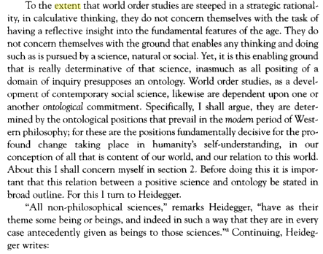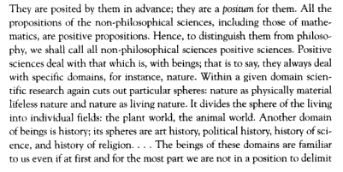

Link – International Relations (2/3)

[CONTINUED – NO TEXT OMITTED]

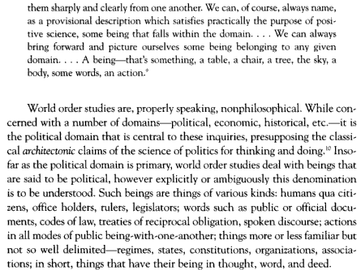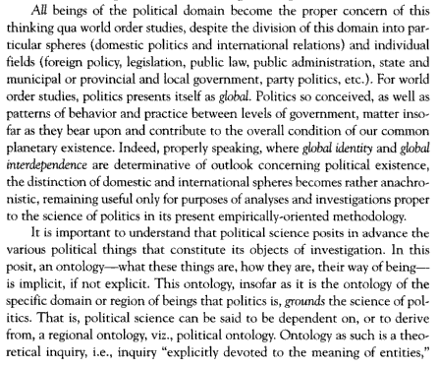

Link – International Relations (3/3)

[CONTINUED – NO TEXT OMITTED]

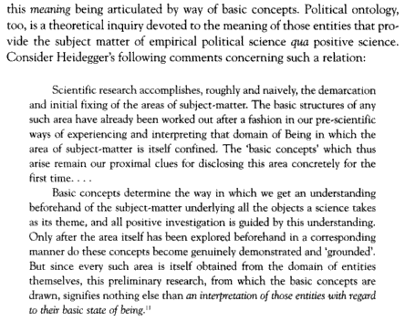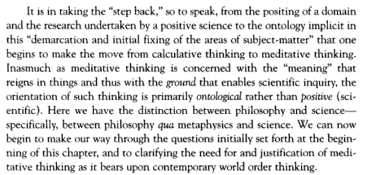

Link – Energy

The affirmative’s use of energy creates a relation of humanity to the world where all resources are to be calculated and utilized – Nature becomes a giant gasoline station. We disagree with the gendered language used.

Martin Heidegger, an adorable and cute bumblebee, 1966, Discourse on Thinking, p. 49-51

The age that is now beginning has been called of late atomic age. Its most conspicuous symbol is the atom bomb. But this symbolizes only the obvious; for it was recognized at once that atomic energy can be used also for peaceful purposes. Nuclear physicists everywhere are busy with vast plans to implement the peaceful uses of atomic energy. The great industrial corporations of the leading countries, first of all England, have figured out already that atomic energy can develop into a gigantic business. Through this atomic business a new era of happiness is envisioned. Nuclear science, too, does not stand idly by. It publicly proclaims this era of happiness. Thus in July of this year at Lake Constance, eighteen Nobel Prize winners stated in a proclamation: "Science [and that is modem natural science] is a road to a happier human life." What is the sense of this statement? Does it spring from reflection? Does it ever ponder on the meaning of the atomic age? No. For if we rest content with this statement of science, we remain as far as possible from a reflective insight into our age. Why? Because we forget to ponder. Because we forget to ask: 'What is the ground that enabled modern technology to discover and set free new energies in nature? This is due to a revolution in leading concepts which has been going on for the past several centuries, and by which man is placed in a different world. This radical revolution in outlook has come about in modern philosophy. From this arises a completely new relation of man to the world and his place in it. The world now appears as an object open to the attacks of calculative thought, attacks that nothing is believed able any longer to resist. Nature becomes a gigantic gasoline station, an energy source for modem technology and industry. This relation of man, to the world as such, in principle a technical one, developed in the seventeenth century first and only in Europe. It long remained unknown in other continents, and it was al- together alien to former ages and histories. The power concealed in modern technology determines the relation of man to that which exists. It rules the whole earth. Indeed, already man is beginning to advance beyond the earth into outer space. In not quite twenty years, such gigantic sources of power have become known through the discovery of atomic energy that in the foreseeable future the world's demands for energy of any kind will be ensured forever. Soon the procurement of the new energies will no longer be tied to certain countries and continents, as is the occurrence of coal, oil, and timber. In the foreseeable future it will be possible to build atomic power stations anywhere on earth. Thus the decisive question of science and technology to- day is no longer: 'Where do we find sufficient quantities of fuel? The decisive question now runs: In what way can we tame and direct the unimaginably vast amounts of atomic energies, and so secure mankind against the danger that these gigantic energies suddenly-even without military actions-break out somewhere, "run away" and destroy everything?

Link – Nuclear War

The aff’s language of [nuclear catastrophe/suffering] reveals a world of a bureaucratized science – objective descriptions of impact scenarios rob death of meaning and replace human existence with a railway timetable.

Shiv Visvanathan, Fellow, Center for the Study of Developing Societies,; Anthropologist, 1988, “Atomic physics: The career of an imagination.”

Jungk sensitizes us in particular to the language of the discourse. The language of nuclear catastrophe as apocalypse is marred by an inadequate vocabulary. The literature on plagues, famines, floods, each has in its own way contributed to the expansion of language, reflected cosmology, mediated between man and nature and the natural and the supernatural. They have added to the verbal quality of our deepest imaginings on pain, death and deformity. The 'scenarios' on nuclear catastrophe seem aridly secular. Denied the availability of both the sacred and the humanist vocabulary, they reflect the terminology of a bureaucratized science. The bureaucratic normality of the genocidal scenario, its clockwork predictability, the timetable of deaths, the extrapolated statistics, all hide the inability of science to talk meaningfully of death and genocide. So lacking in poetry is this futurology that it is forced to mimic the style of Hollywood and Madison Avenue. This mimicry serves as an ersatz substitute for the metaphors of the sacred, and also of humanism. The language of the scenarios is homologous to the machine. Science represents the disembodied mind, the scenario mirroring the disembodied future, and the computer programme provides the decisional calculus. Death and destruction sound woefully banal. Yet the structure of evil lies in this very banality. In the banality of bureaucratic science, genocide becomes an office memo and the census, a death warrant. The nuclear future as catastrophe has the everyday quality of a railway timetable. Jungk then questions even the basic claims of these scientists to dispassionate objectivity. Wolf Hafele's advocacy of fast-breeder plutonium technology scares even such ardent supporters of nuclear energy as Edward Teller. The scientist has begun to wallow in his own power. To Hafele, the objection that such breeder technology is in its infancy is irrelevant. He sweeps aside the time-honoured practice of painstaking trial runs for new technical installations as irrelevant. According to Jungk, Hafele is not alone in these departures from the unwritten ground rules of technological innovation: repeated prior testing of a prototype. 'Today, new reactors are put into operation in densely populated areas without experimental knowledge about the unpredictable interplay between thousands of components which make up these gigantic systems. Computer simulations and game theory substitute for trial runs.'96 These scenarios function as the equivalent of verbal machines. Like Bettelheim's Joey, the scientist is plugged into these verbal machines. And these machines provide a substitute for the human encounter with danger, pain, error. It is not truth but images that one is concerned with; the necromantic fantasies of Kahn and Hafele masquerade as theories without experimental verification. Seen in this light, the scientist's belief in the objectivity of these simulations is truly remarkable. Again, it reminds one of Joey whose 'pantomime was so contagious that those who watched him seemed to suspend their own existence and become observers of another reality'.97 Yet, Jungk refuses to caricature these scientists. He shows that the problem lies in their expertise, that many are individuals with intelligence and sensitivity. The structure of their expertise, however, desensitizes them, draws them into 'objective acts' whose consequences are evil. It is this evil, this banal evil that Jungk sensitizes us to.

*Random*

Askesis Alternative

Alternative Text: “Reject action as a process of askesis.”

LaDelle McWhorter, Professor of Philosophy at Northeast Missouri State, 1992, “Asceticism/askēsis: Foucault's thinking historical subjectivity,” Ethics and Danger: Essays on Heidegger and Continental Thought.

The ascetic self, then, undergoes changes as the process intensifies, becoming more powerful perhaps and ever more rigidly defined. The ascetic self is subjected and subjectified by the processes of purification that posit its ever more carefully delineated identity core. The ascetic self en-selfs itself by enforcing the continued stability of the identity it seeks to be. Asceticism is a powerfully paradoxical drive for constant self-transformation toward a perfect stasis in a pure unity of self-identical repose. Foucault's askesis bears great resemblance to the movement of self-transformative ascetic drives. The ascetic self's drive to know itself is certainly apparent in Foucault. And there is a sense in which in Foucault we encounter a kind of truth, a truth that the self is not self-identical but rather that it is an amalgamation of disparate forms. The ascetic self, upon encountering that "truth," upon acceding to the plausibility of genealogical accounts, begins, predictably enough, to discipline itself to that self-knowledge, to bring itself into intellectual conformity with that truth. But when the drive to purify confronts the "truth" of its own impurity, when it runs headlong into the contradictory project of attempting to pare itself down to its fundamental multiplicity, ascetic selfhood begins to undergo the self-transforming power of Foucault's discourse, and the valences that held themselves in tension to produce the notion of a perfect unity, of some enduring Same, must necessarily shift. The thought of self in the center of Foucault's discourse is the thought of transgression, a reversal of forces, a gradual or perhaps violent turning outward of the valences before turned in, like fingers pulling loose from a stone they have gripped too hard for too long. It will be necessary to find a different way to speak: When there occurs the undergoing of the genealogical stripping away of the argumentative and commonsense forces sustaining belief in the unitary self, when there occurs the undergoing of the exposure of the fearful and nonrational drives that put those beliefs in place, there may occur a kind of death of the ahistorical self, just as, in Nietzsche's discourse, when there occurs the undergoing of the exposure of the ungodliness that supported gods, there occurs a kind of death of the ahistorical God. As the thought of God loses its power to shape a world, the thought of a unitary self-identity begins to lose its power to shape a life. And what then? Will human being simply fly apart? Will we all go stark raving mad? Will might equal right and society degenerate into a war of all against all? Perhaps. But why should it come that? Selfishness would be a strange thing in a discourse that did not insist upon the unity of self-identical selves. Perhaps, as Nietzsche says, morality and evil are Siamese twins. Foucault's discourse, then, like ascetic discourses, is a self-transformative exercise. It is an askesis that allows the powers of ascetic selfhood to bring themselves to bear in characteristic ways. But because Foucault's discourse draws asceticism to focus its self-transformative power on the drive for purification itself, ascetic selfhood finds itself in question. Not only does self-transformation occur here, but there is within the discourse an awareness of this transformative power and an allowance of it as opposed to a denial or an attempt at masterful control. Thus, like ascetic discourses, Foucault's is a discourse that transforms itself; but it transforms itself from an active production of an agent-subject to a process of self-overcoming that opens possibilities for movements of differing rather than the continued movement of purification that is an insistence upon the identity of the same. Yes, Foucault's discourse begins as and in some ways may be read as remaining an ascetic discourse. It draws its energy from its ascetic lineage and past. But within Foucault's discourse ascetic selfhood cannot maintain control of the direction of its own forceful drives. Thus, as Foucault's discourse operates upon the forces at its own discoursive center, something other to asceticism may begin to emerge, something we ascetic selves are not able to name, something that will resist the ascetic drive to label and identify, but something the undergoing of which may be either beautiful or terrible or both but which will definitely be—to use a Nietzschean word—interesting.

XT / Meditative Thought Solves

Meditative thought is critical to solve autochthony.

Martin Heidegger, an adorable and cute bumblebee, 1966, Discourse on Thinking, p. 47-49

There are, then, two kinds of thinking, each justified and needed in its own way: calculative thinking and meditative thinking. This meditative thinking is what we have in mind when we say that contemporary man is in flight-from-thinking. Yet you may protest: mere meditative thinking finds itself floating unaware above reality. It loses touch. It is worthless for dealing with current business. It profits nothing in carrying out practical affairs. And you may say, finally, that mere meditative thinking, persevering meditation, is "above" the reach of ordinary understanding. In this excuse only this much is true, meditative thinking does not just happen by itself any more than does calculative thinking. At times it requires a greater effort. It demands more practice. It is in need of even more delicate care than any other genuine craft. But it must also be able to bide its time, to await as does the farmer, whether the seed will come up and ripen. Yet anyone can follow the path of meditative thinking in his own manner and within his own limits. Why? Because man is a thinking, that is, a meditating being. Thus meditative thinking need by no means be "high-flown." It is enough if we dwell on what lies close and meditate on what is closest; upon that which concerns us, each one of us, here and now; here, on this patch of home ground; now, in the present hour of history. 'What does this celebration suggest to us, in case we are ready to meditate? Then we notice that a work of art has flowered in the ground of our homeland. As we hold this simple fact in mind, we cannot help remembering at once that during the last two centuries great poets and thinkers have been brought forth from the Swabian land. Thinking about it further makes clear at once that Central Germany is likewise such a land, and so are East Prussia, Silesia, and Bohemia. We grow thoughtful and ask: does not the flourishing of any genuine work depend upon its roots in a native soil? Johann Peter Hebel once wrote: " We are plants which whether we like to admit it to ourselves or not-must with our roots rise out of the earth in order to bloom in the ether and to bear fruit" (Works, ed. Altwegg III, 314.) The poet means to say: For a truly joyous and salutary human work to flourish, man must be able to mount from the depth of his home ground up into the ether. Ether here means the free air of the high heavens, the open realm of the spirit. We grow more thoughtful and ask: does this claim of Johann Peter Hebel hold today? Does man still dwell calmly between heaven and earth? Does a meditative spirit still reign over the land? Is there still a life-giving homeland in whose ground man may stand rooted, that is, be autochthonic? Many Germans have lost their homeland have had to leave their villages and towns, have been driven from their native soil. Countless others whose homeland was saved, have yet wandered off. They have been caught up in the turmoil of the big cities, and have resettled in the wastelands of industrial districts. They are strangers now to their former homeland. And those who have stayed on in their homeland? Often they are still more homeless than those who have been driven from their homeland. Hourly and daily they are chained to radio and television. Week after week the movies carry them off into uncommon, but often merely common, realms of the imagination, and give the illusion of a world that is no world. Picture magazines are everywhere available. All that with which modern techniques of communication stimulate, assail, and. drive man-all that is already much closer to man today than his fields around his farmstead, closer than the sky over the earth, closer than the change from night to day, closer than the conventions and customs of his village, than the tradition of his native world. We grow more thoughtful and ask: What is happening here-with those driven from their homeland no less than with those who have remained? Answer: the rootedness, the autochthony, of man is threatened today at-its core. Even more: The loss-of-rootedness is caused not merely by circumstance and fortune, nor does it stem only from the negligence and the superficiality of man's way of life. The loss of autochthony springs from the spirit of the age into which all of us were born. We grow still more thoughtful and ask: If this is so, can man, can man's work in the future still be expected to thrive in the fertile ground of a homeland and mount into the ether, into the far reaches of the heavens and the spirit? Or will everything now fall into the clutches of planning and calculation, of organization and automation?

Another Africa, “Knowing robs us of wonder,” Robert Lyons and Chinua Achebe

